* **Comparable Interface**:

The `Comparable` interface is used to define the **natural ordering** of objects. It allows an object to compare itself with another object of the same type. The interface has one method:

public int compareTo(T o);

Return Value:

Negative: If the current object is less than the other object.

Zero: If the current object is equal to the other object.

Positive: If the current object is greater than the other object.

Code Explanation

In your code, the `Student` class implements `Comparable<Student>`:

java

class Student implements Comparable<Student> {

int rollno;

String name;

Student(int rollno, String name) {

this.rollno = rollno;

this.name = name;

}

@Override

public int compareTo(Student other) {

return this.rollno - other.rollno; // Natural ordering based on rollno

}

@Override

public String toString() {

return "[" + rollno + ", " + name + "]";

}

}

**Natural Ordering**: The `compareTo` method defines the natural ordering of `Student` objects based on their `rollno`. This means that when you sort a list of `Student` objects, they will be ordered by their `rollno`.

Usage Example

import java.util.*;

public class Main {

public static void main(String[] args) {

List<Student> students = new ArrayList<>();

students.add(new Student(3, "Charlie"));

students.add(new Student(1, "Alice"));

students.add(new Student(2, "Bob"));

// Sorting using natural ordering (defined by compareTo)

Collections.sort(students);

System.out.println(students); // Output: [[1, Alice], [2, Bob], [3, Charlie]]

}

}

Key Points:

- The `Collections.sort()` method uses the `compareTo` method defined in the `Comparable` interface to sort the list.

- The `toString()` method is overridden to provide a readable representation of the `Student` objects.

* **Comparator Interface**

The `Comparator` interface is used to define **custom ordering** for objects. Unlike `Comparable`, which defines the natural ordering, `Comparator` allows you to define multiple sorting criteria for the same class.

The interface has one key method:

public int compare(T o1, T o2);

Return Value:

- Negative: If `o1` is less than `o2`.

- Zero: If `o1` is equal to `o2`.

- Positive: If `o1` is greater than `o2`.

Why Use Comparator?

- When you want to sort objects in a way that differs from their natural ordering.

- When you cannot modify the original class (e.g., if it's part of a library).

Example Using Comparator

You can create a `Comparator` to sort `Student` objects by `name` instead of `rollno`:

import java.util.*;

public class Main {

public static void main(String[] args) {

List<Student> students = new ArrayList<>();

students.add(new Student(3, "Charlie"));

students.add(new Student(1, "Alice"));

students.add(new Student(2, "Bob"));

// Sorting using a custom Comparator (by name)

Comparator<Student> nameComparator = new Comparator<Student>() {

@Override

public int compare(Student s1, Student s2) {

return s1.name.compareTo(s2.name); // Compare names lexicographically

}

};

Collections.sort(students, nameComparator);

System.out.println(students); // Output: [[1, Alice], [2, Bob], [3, Charlie]]

}

}

Differences Between `Comparable` and `Comparator`

| Feature | `Comparable` | `Comparator` |

|--------------------------|-------------------------------------------|-------------------------------------------|

| **Purpose** | Defines the natural ordering of a class. | Defines custom ordering for a class. |

| **Method** | `compareTo(T o)` | `compare(T o1, T o2)` |

| **Location** | Implemented in the class itself. | Implemented externally (as a separate class or lambda). |

| **Flexibility** | Limited to one natural ordering. | Allows multiple sorting criteria. |

| **Use Case** | When the class controls its own ordering.| When you need additional sorting logic. |

Ways to Use `Comparator`

a. **Anonymous Class**

You can define a `Comparator` using an anonymous class:

Comparator<Student> nameComparator = new Comparator<Student>() {

@Override

public int compare(Student s1, Student s2) {

return s1.name.compareTo(s2.name);

}

};

Lambda Expression (Java 8+)

Lambda expressions simplify the creation of `Comparator` instances:

Comparator<Student> nameComparator = (s1, s2) -> s1.name.compareTo(s2.name);

Method References

If the comparison logic is already defined in a method, you can use a method reference:

Comparator<Student> nameComparator = Comparator.comparing(s -> s.name);

Or even shorter:

Comparator<Student> nameComparator = Comparator.comparing(Student::getName);

Chained Comparators

You can chain multiple comparators to define complex sorting logic:

Comparator<Student> rollnoThenNameComparator = Comparator

.comparingInt(Student::getRollno)

.thenComparing(Student::getName);

Important Things to Know

a. Stability of Sorting

- Sorting algorithms like `Collections.sort()` are **stable**, meaning that equal elements retain their relative order.

b. Null Handling

- Both `Comparable` and `Comparator` can throw `NullPointerException` if `null` values are compared.

- To handle `null` values, you can use `Comparator.nullsFirst()` or `Comparator.nullsLast()`:

Comparator<Student> nullSafeComparator = Comparator.comparing(Student::getName, Comparator.nullsFirst(Comparator.naturalOrder()));

c. Reverse Order

- You can reverse the order of a `Comparator` using `reversed()`:

Comparator<Student> reverseNameComparator = Comparator.comparing(Student::getName).reversed();

d. Primitive-Specific Comparators

- For primitive types, use specialized comparators like `Comparator.comparingInt()`, `Comparator.comparingDouble()`, etc., for better performance.

Comparator<Student> rollnoComparator = Comparator.comparingInt(Student::getRollno)

Summary of Usage Patterns

| Pattern | Example |

|--------------------------|-------------------------------------------------------------------------|

| Comparable (Natural) | `Collections.sort(students);` |

| Comparator (Anonymous) | `Collections.sort(students, new Comparator<Student>() { ... });` |

| Comparator (Lambda) | `Collections.sort(students, (s1, s2) -> s1.name.compareTo(s2.name));` |

| Comparator (Method Ref) | `Collections.sort(students, Comparator.comparing(Student::getName));` |

| Chained Comparators | `Comparator.comparingInt(Student::getRollno).thenComparing(Student::getName);` |

| Null-Safe Comparator | `Comparator.comparing(Student::getName, Comparator.nullsFirst(...));` |

| Reverse Order | `Comparator.comparing(Student::getName).reversed();` |

Final Answer

- Comparable is used to define the **natural ordering** of objects within the class itself.

- Comparator is used to define **custom ordering** externally, allowing flexibility for multiple sorting criteria.

- Both can be implemented using traditional methods, anonymous classes, lambda expressions, or method references.

- Key features include handling `null` values, reversing order, chaining comparators, and optimizing for primitives.

By understanding and leveraging both `Comparable` and `Comparator`, you can write flexible and efficient sorting logic in Java.

**Exception Handling**

An exception is an unwanted or unexpected event, which occurs during the execution of a program i.e. at run time, that disrupts the normal flow of the program.

When such unexpected event and we solve it with alternate way and we called it as Exception handling

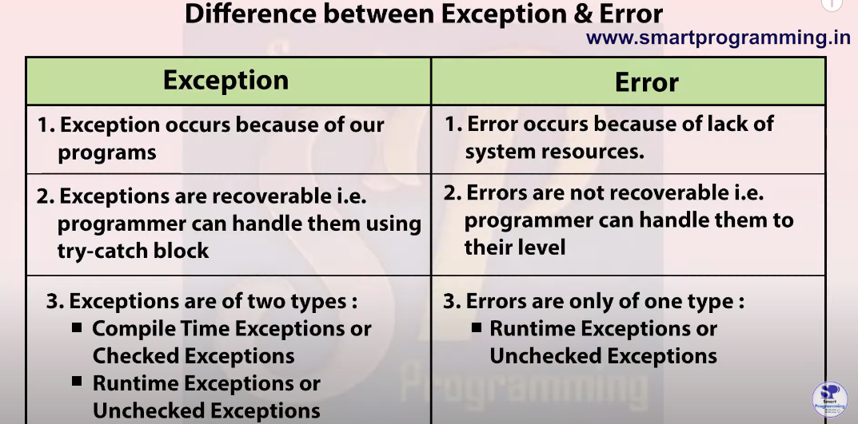

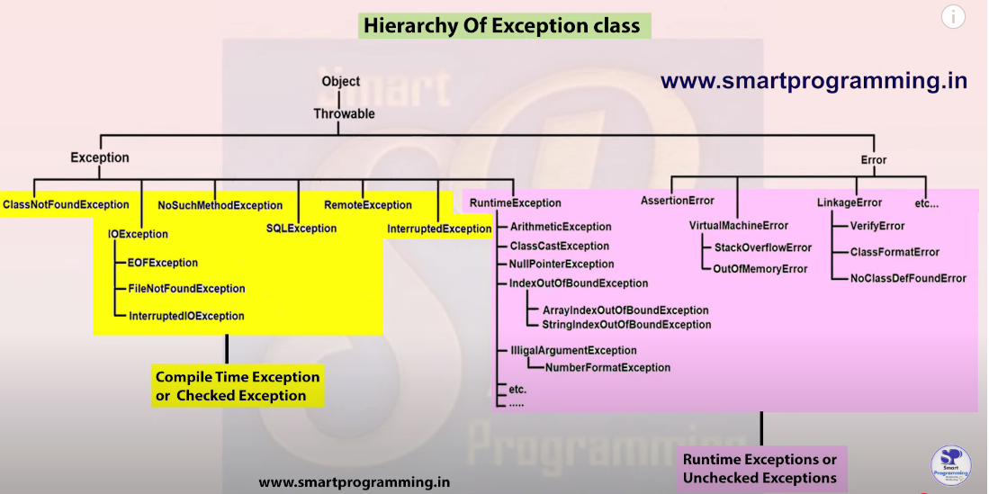

Exceptions always occur at runtime. **Exception does not occur at compile time.**

Compile time pe compiler warn karta hai ki future mai ye exception aa sakti hai isse handle karo (using try-catch) aur ye exception nhi hota. Jab ham warning ko handle kar lete hai tab code compile hoga but jo warning mili thi waise hi problem hai to runtime pe exception aaegi.

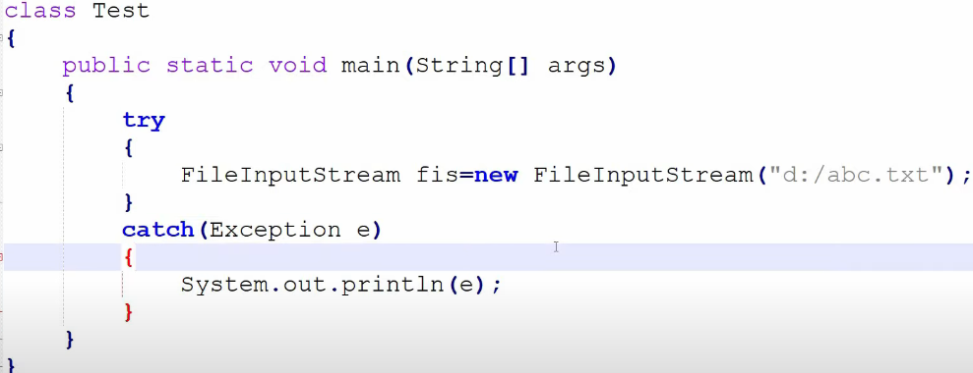

Abc.txt does not exists.

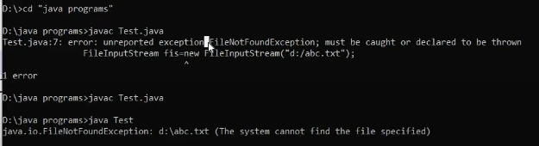

1st compiler bata raha hai warn kar rha hai

2nd exception occur hui

**Checked** Exception (**Compile** time exception)

Aisi exception jo compiler apne level pe check kar sakta hai aur bolta hai isse handle karo (try-cath, throw, throws).

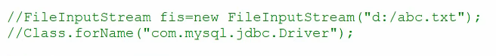

**Unchecked** Exception (**Runtime** exception)

In unchecked compiler is not able to check the exception. Compiler Ignore it.

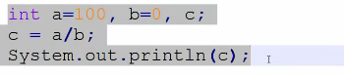

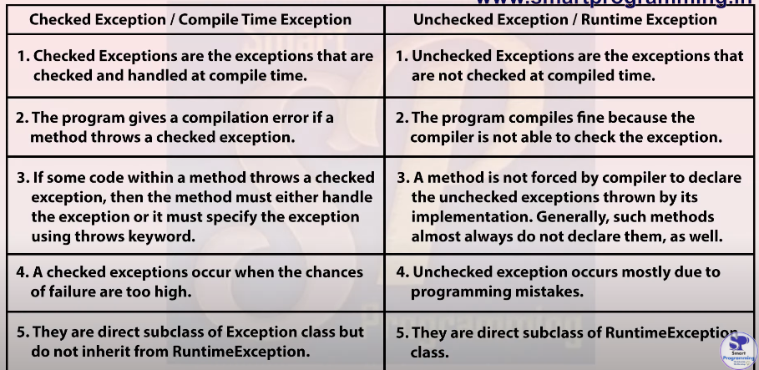

How to handle exception (Checked & Unchecked).

Whenever there is exception, the method in which exception occurs will create an object and that object will store three things.

1. Exception name
2. Description
3. Stack trace (Proper long description)

JVM Default Exception Handler (method) ye object pass kar dega agar use handle nhi kiya gya hai aur use pehle program abnormally terminate ho jaega.

We can handle the exception using 5 keywords

1. Try
2. Catch
3. Finally
4. Throw
5. Throws

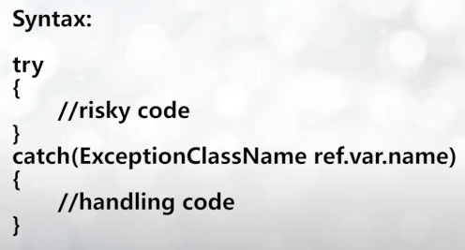

Flow of try-catch

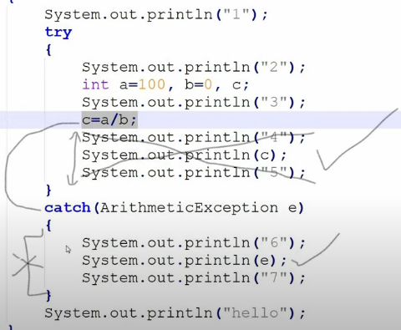

Printing Exception

1. E.printStackTrace() (Most Used)

Name, description, stack trace (line)

1. Sout(e)

Name, description

1. Sout(e.getMessage())

description

**Finally** Block:

Always executes whether exception occurred or not. It is used to write a **clean up code** like closing db connection, resources that we tried to open in try we will close that in finally block.

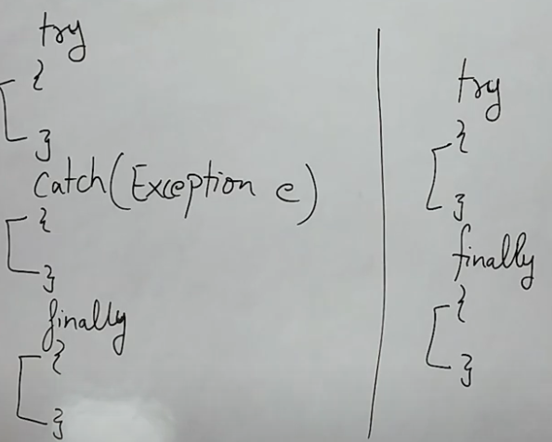

Try ke baad directly finally use kar sakte hai but exception handle nhi hoga. Preferred way to use is try-catch-finally

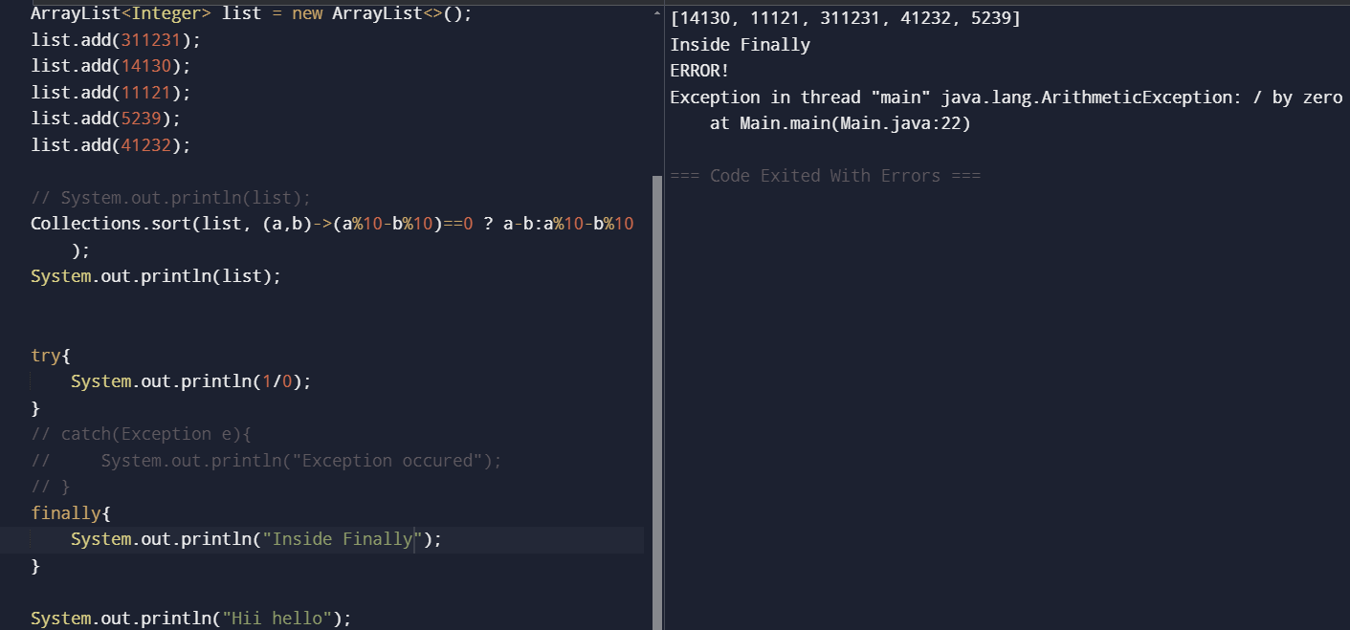

Akela try, catch or finally block nhi allowed hai compilation error

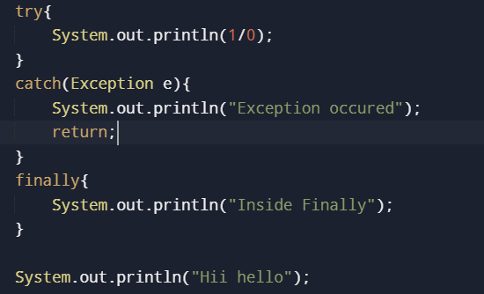

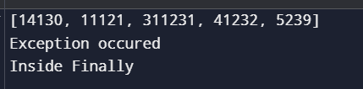

If return is in try or catch block than also finally will run but below finally codes will not run

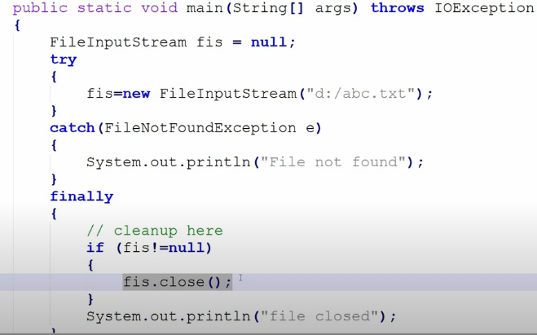

We can use multiple catch blocks with one try block but we can only use single finally block with one try block, not multiple.

**The statements** present in the finally block execute even if the try block contains control transfer statements (i.e. jump statements) like ***return, break or continue*.**

Four Scenarios where finally block does not execute

1. Using of System.exit(0) method inside try
2. Causing a fatal error that causes the process to abort (outofmememory etc.)
3. Due to exception arising in the finally block
4. The death of a Thread

Difference between **final, finally, finalize**

Finalize method is just executed prior to garbage collector. Clean is performed

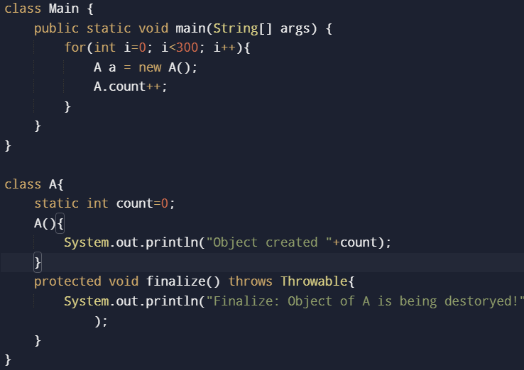

Possible combinations of try-catch-finally

1. Alone any cannot exist
2. Multiple catch block can be used with single try but Parent (Exception) should be last. If it is first than error. Two same classes in catch cannot be provided

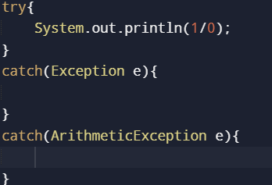

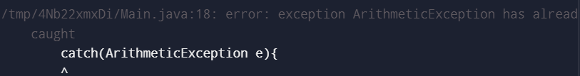

1. Nesting is allowed. Try-Catch can be written inside try, catch, and finally block

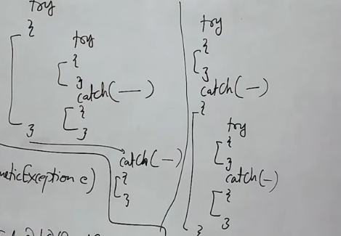

1. Try ke baad finally directly

**Throw**:

Throw keyword is used to throw user defined exceptions. If you use existing exception the program will run fine but that is not recommended. Customized exception ke liye throw keyword use hota hai.

Here a programmer manully creates a exception object using throw keyword. But exception handle karna padega using try-catch kyunki throw bhi abnormally program ko terminate kar dega

throw new UserException();

Check exception when extending to Exception class

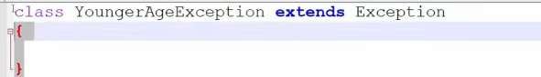

Uncheck

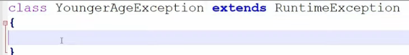

It is better to make customized exception unchecked

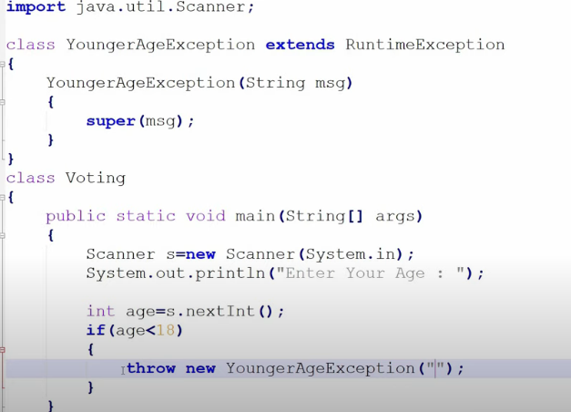

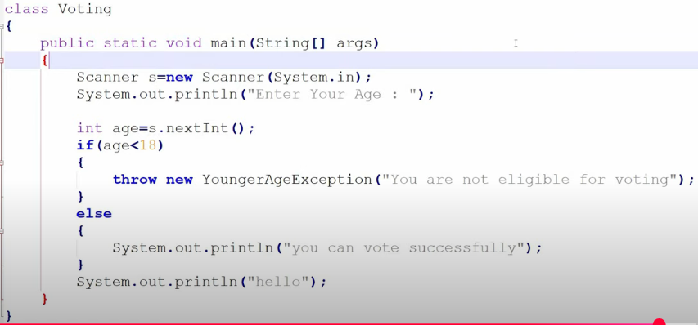

User made a custom exception and had use throw keyword to manually create a exception object. JVM ask main method did you handle this exception main said No than JVM gives the exception object to Default Exception handler DEH and it prints the exception object and program ko abnormally terminate kar dega.

Handling throw exception

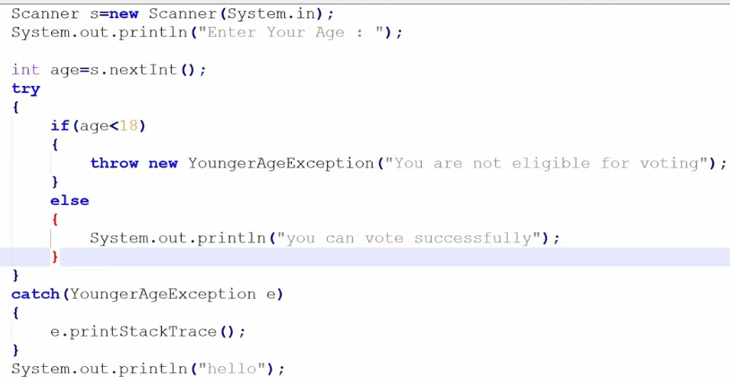

Summary

1. Throw is used to throw user defined exception that are mainly unchecked (RuntimeException)
2. It manually create an exception object and gives it to jvm
3. You cannot write any statement after throw will give compilation error

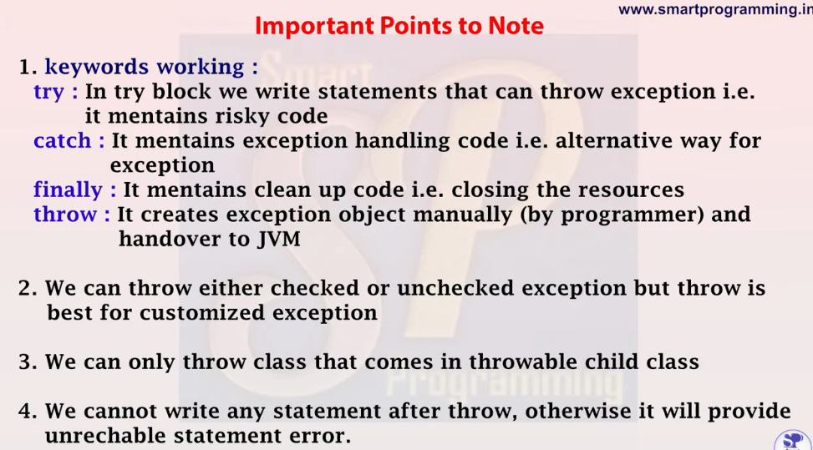

**Throws (**method ke sath use hot hai**)**

Throws keyword is used to declare an exception. It gives an information to the caller method that there may occur an exception so it is better for the caller method to provide the exception handling code so that normal flow can be maintained.

Ye maine ek method bana diya isse tum use karo but be cautious as this method can throw an exception so please handle it.



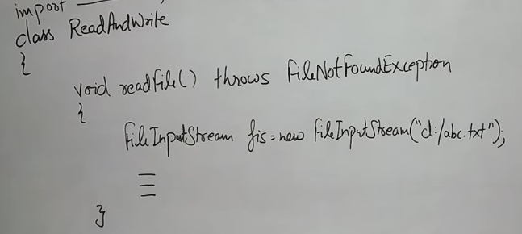



**Throws is used with checked exception**

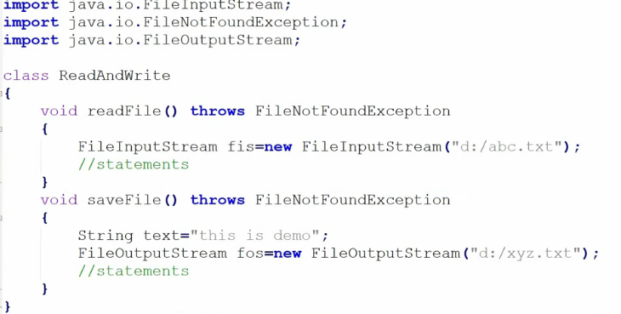

Handling exception

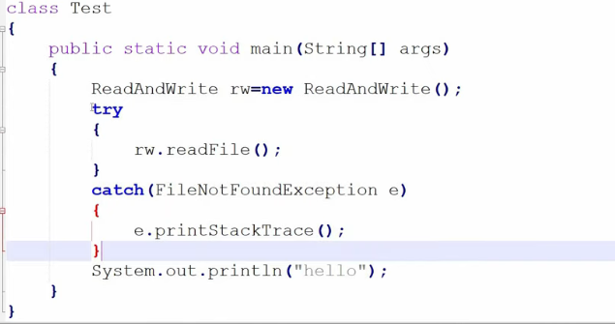

Compiled but will not handle exception and program will terminate abnormally.

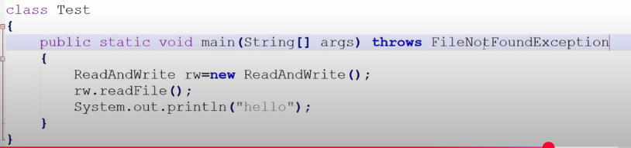



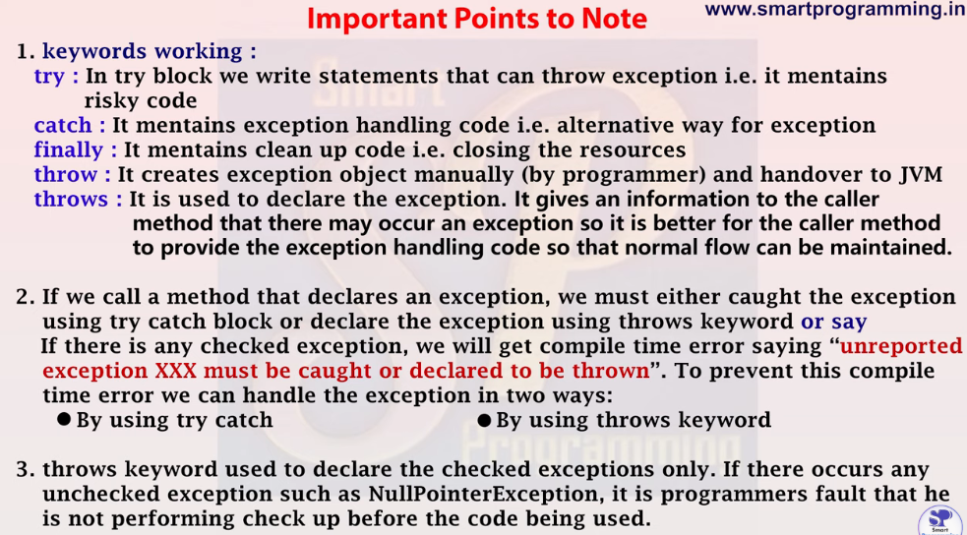

**Difference** between throw and throws

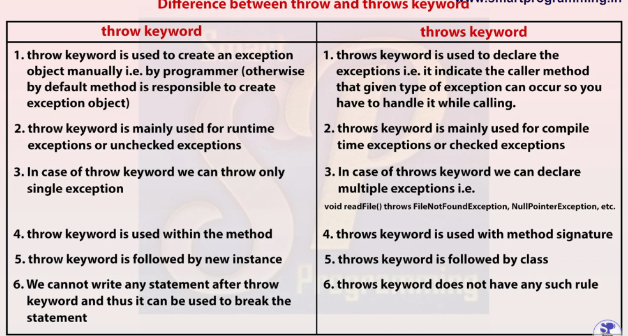

**Custom** Exception

Checked exception so extend Exception class

If throwing an checked exception so use try-catch or throws to compile the code.

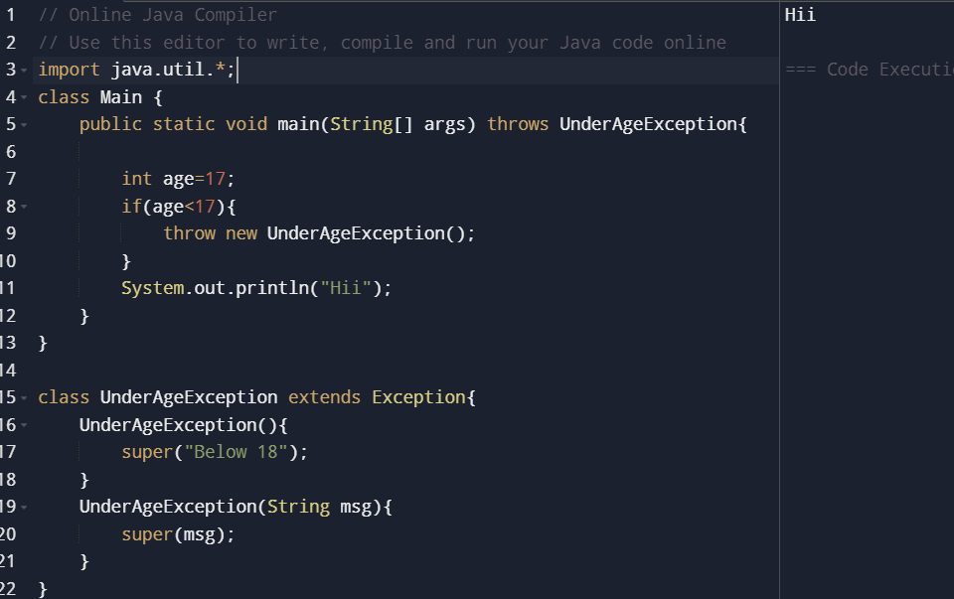

Unchecked exception so extend RuntimeException class

The code will **compile** successfully without try-catch or throws but during runtime it can give exception

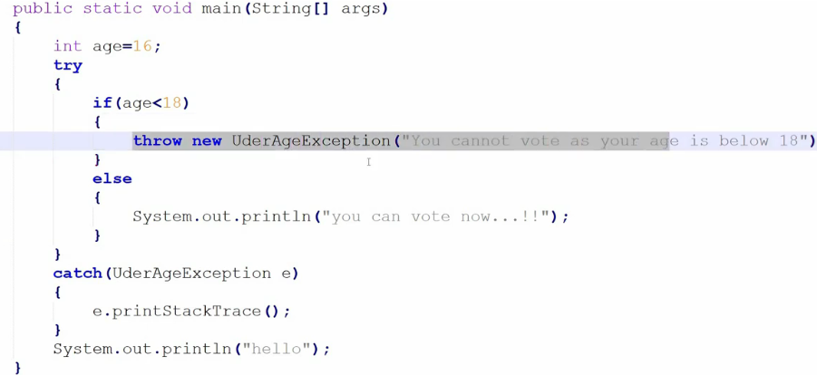

Throw can be used to throw system exception as well as customized exception. But best for throwing customized exception.

**Working of HashMap.**

<https://www.youtube.com/watch?v=sw-j_ETGBEo>

Put(null,null) get stored at 0th index.

In form of ll node key, values are stored if collision occurs than chaining

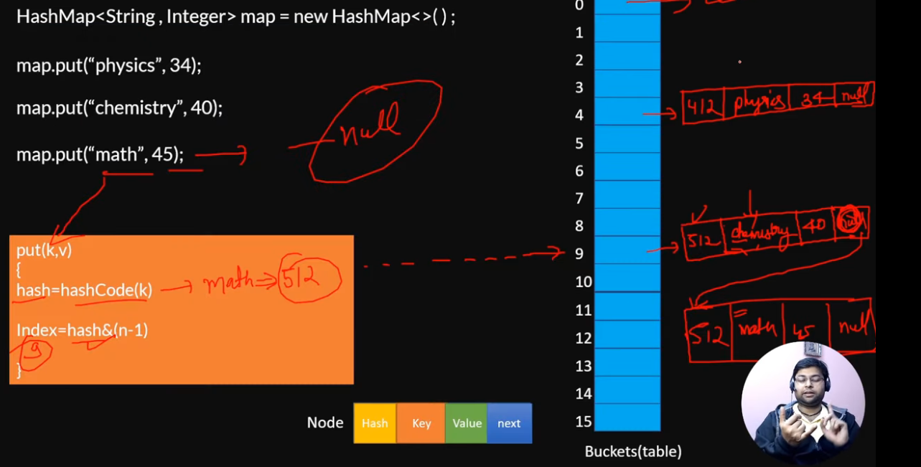

From java 8 onward if there is huge collision and size of a particular bucket increases the threshold than BST is used to reduced the TC of put and get from O(n) to O(logn)

Get Operation:

<https://www.youtube.com/watch?v=X2k-NTmswVs>

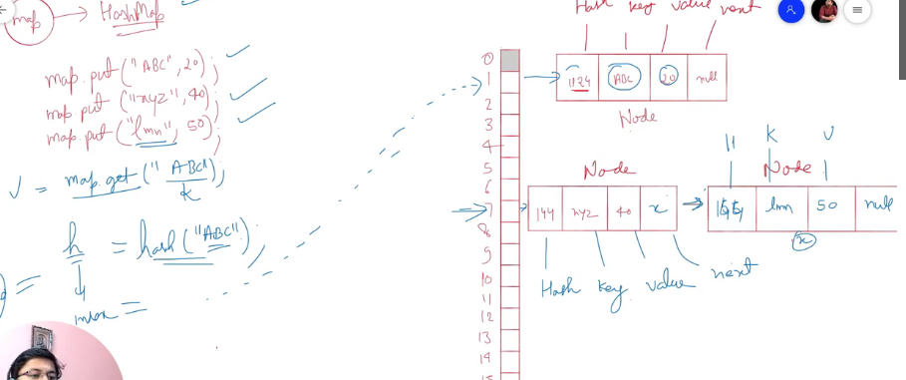

Top 15 Hashmap interview questions.

<https://www.youtube.com/watch?v=OGGHFabY9G4&list=PL0zysOflRCen9SPmMO2XN1I2S9m96G_dx&index=6&t=18s>

HashMap can have **one null key** and any number of null values.

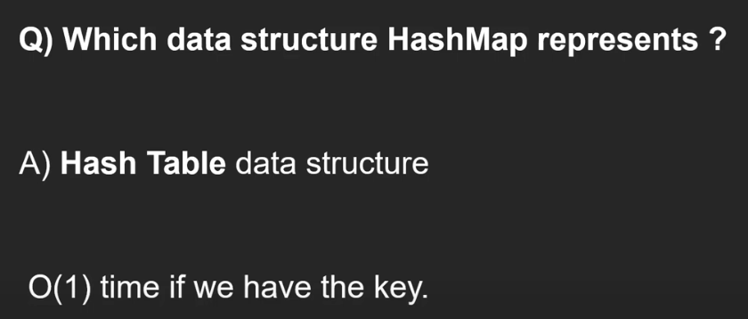

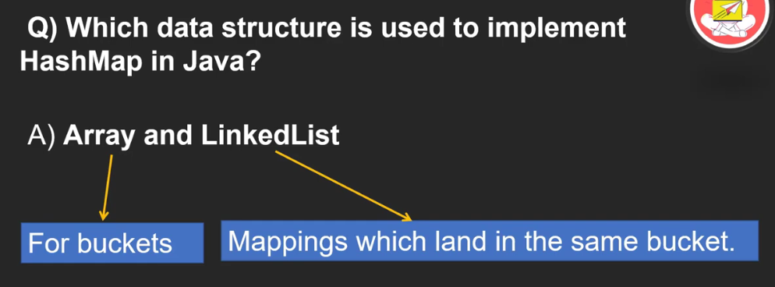

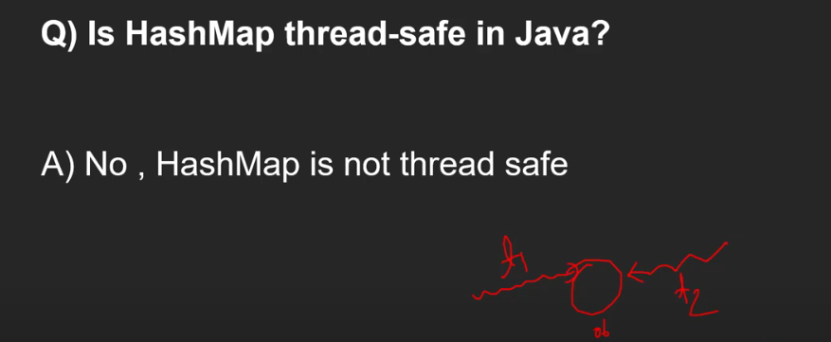

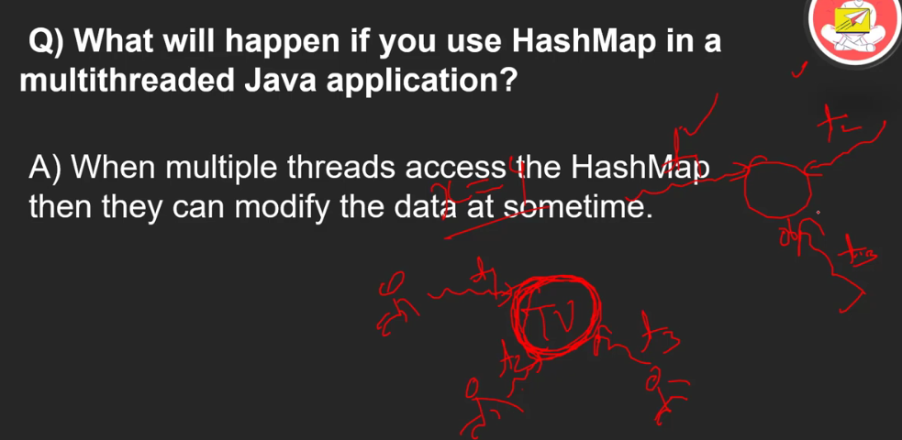

Use ConcurrentHashMap for thread safe

Trying to **remove** key from map while iterating not possible

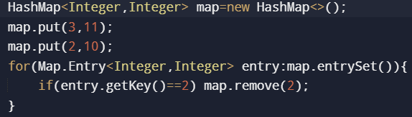

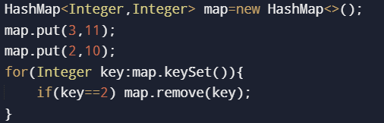

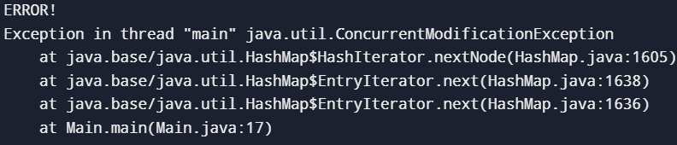

We can use iterator on keyset() and keyentry() to remove while iterating.

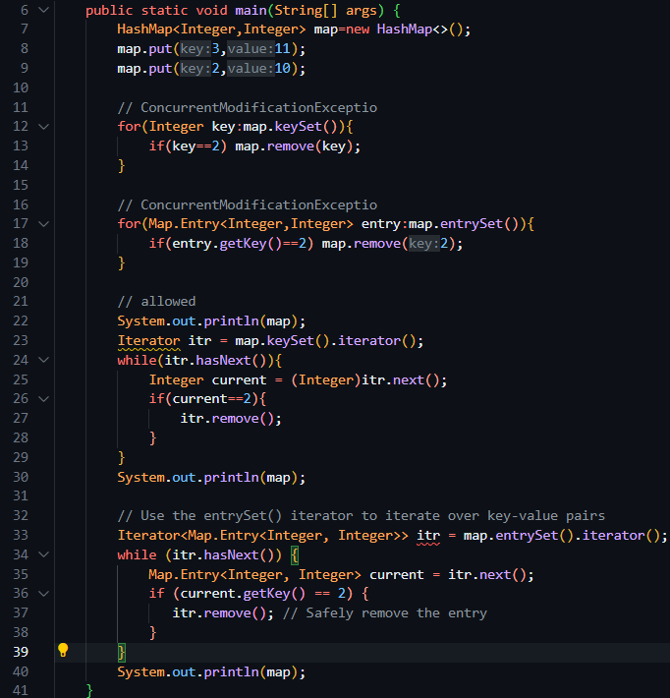

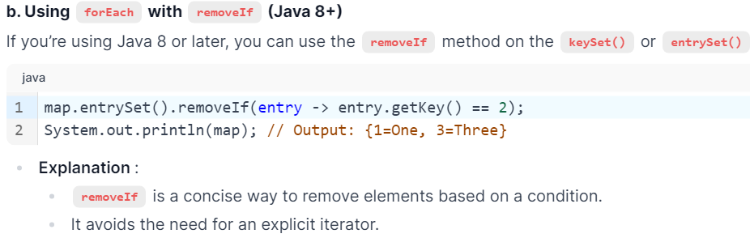

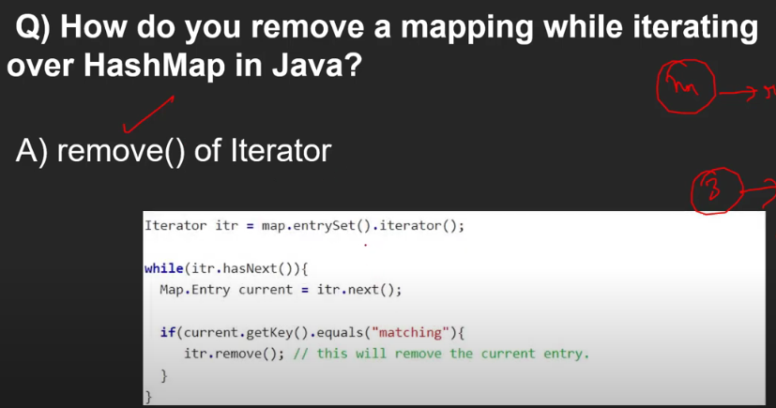

removeIf() can also be used.

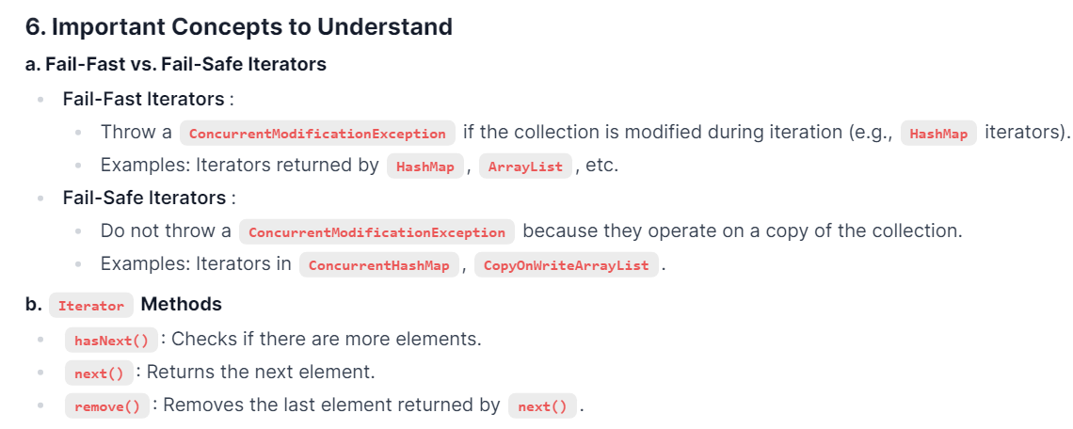

Set:

The same concept applies to **Set**. You cannot modify a **Set** directly while iterating over it using a **for-each** loop or other means. Instead, you must use the **Iterator's remove() method** or the **removeIf method** in Java 8+. Understanding these concepts is crucial for working with Java collections and answering related interview questions effectively.

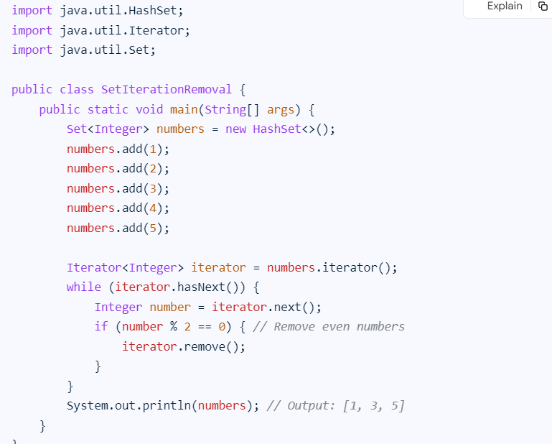

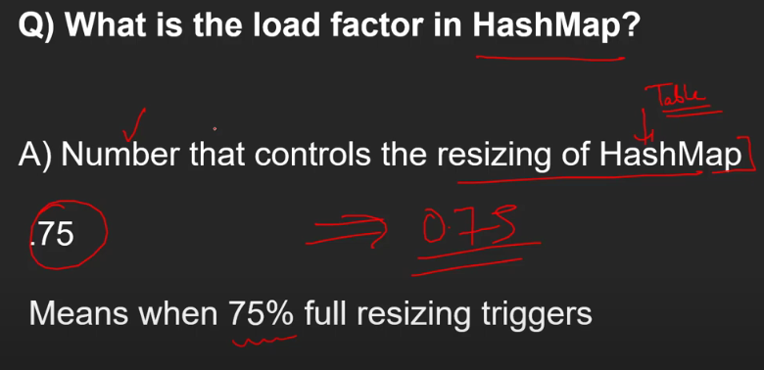

0.75f load factor

Intial capacity 16

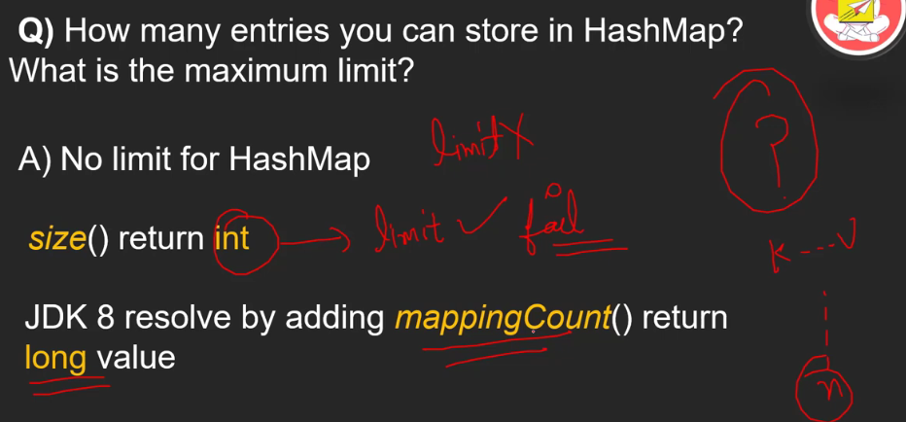

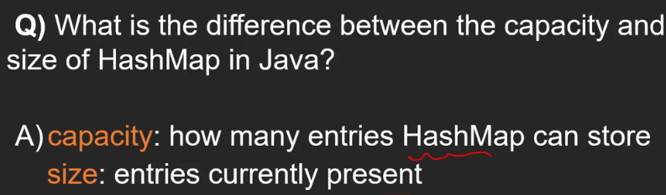

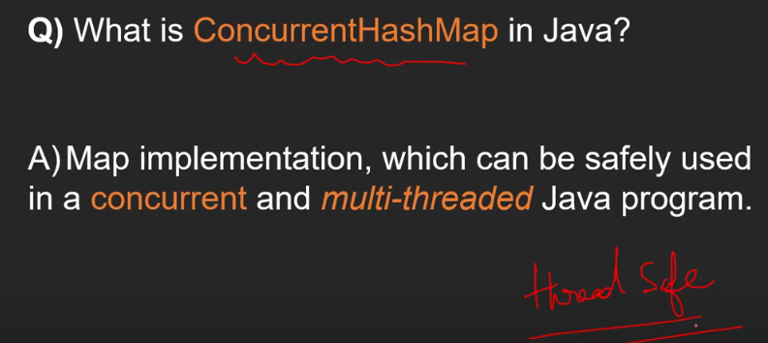

HashTable, Collections.synchrinizedMap(normal_map) and ConcurrentHashMap are both implementation on Map and are thread safe

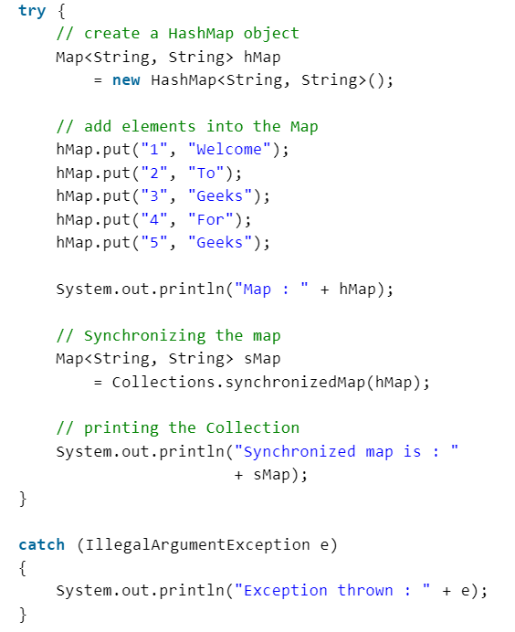

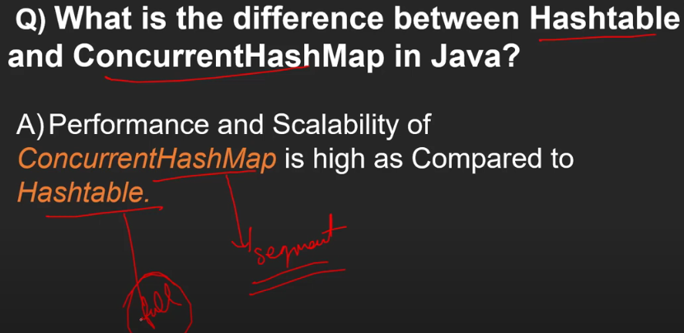

ConcurrentHashMap kuch segments ko lock karta where as Hashtable pure Object ko lock kar deta hai

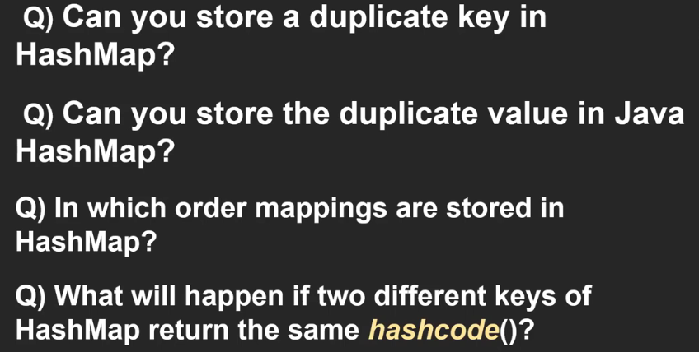

1. No
2. Yes
3. No order
4. Collison (chaining used with ll)



**Serialization** and **Deserialization**: (Asked in IO)

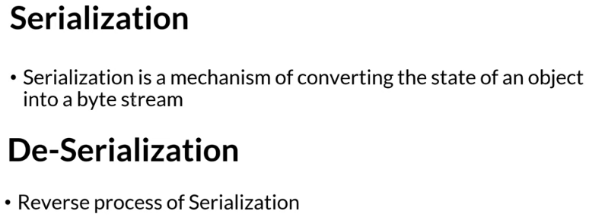

Object State meaning: Us object ke pass active properties hogi, attributes and behavior hogi

After doing Serialization we can transfer object state to **Network**, can store in **Database**, can save in **File**

Again by doing Deserialization we can access the state object received from network, fetched from database or retrieved from file.

When we have a object we cannot transfer it through network. First we have convert it to Byte stream by doing Serialization.

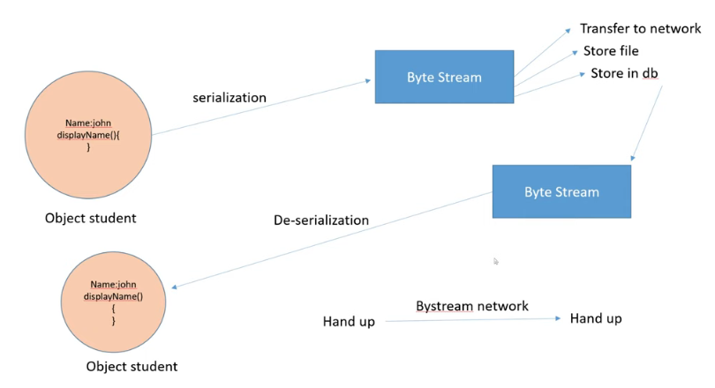

Same state ko transfer kar sakte hai and receiving system us same state ko access kar sakta hai

**Serializable** is a markup interface that tells if a class object is serializable or not.



**Transient** is a keyword which prevents a variable from serializable

Serialization

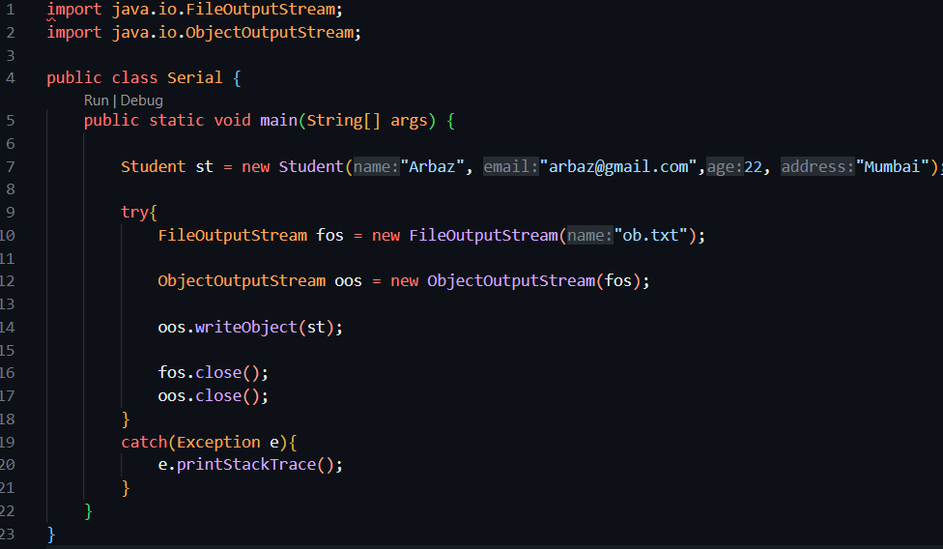

Deserialization

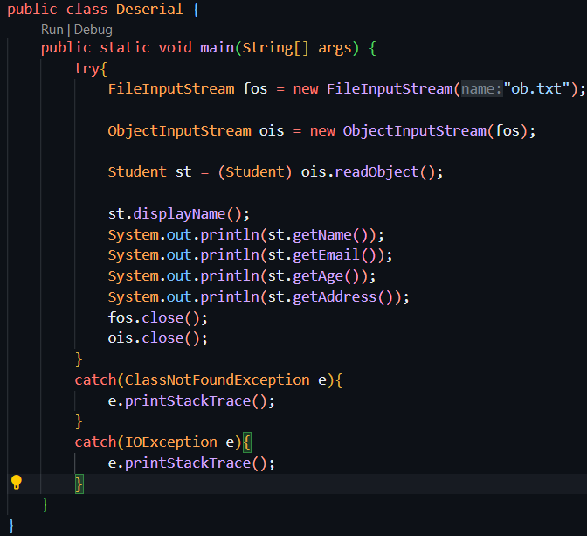

Important class for Serialization

FileOutputStream and ObjectOutputStream

Method: writeObject(obj)

Important class for Deserialization

FileInputStream and ObjectInputStream

Method: readObject()

**Multi -Threading**

**(**Java is Multi-Threading Programming Language**)**

Multi threading is used to achieve Multi tasking

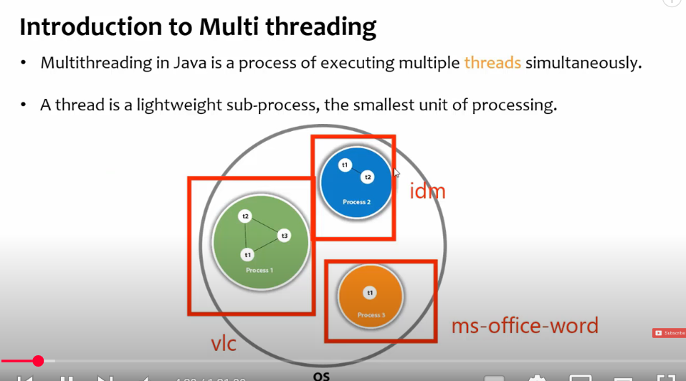

Multi threads forms a process.

IDM – Internet Download Manager

Multi Processing occurs at OS level when Multiple processes runs.

Multi Threading occurs within a single process. The application is developed using a language that supports multi threading. So Multi threading is programming level phenomenon occurs within a single process .

For a Process there needs to be at least one thread.

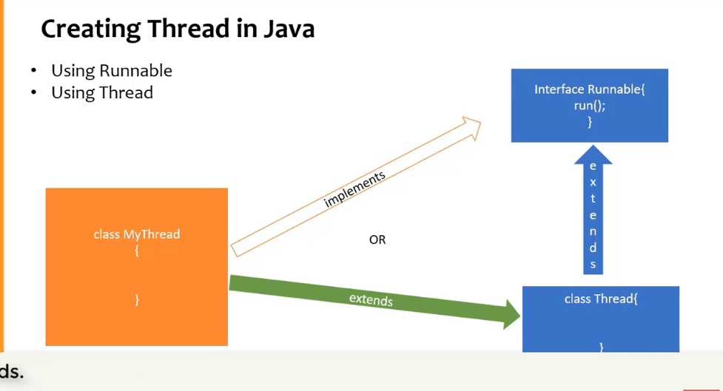

Both are in java.lang package so no need to explicitly import anything.

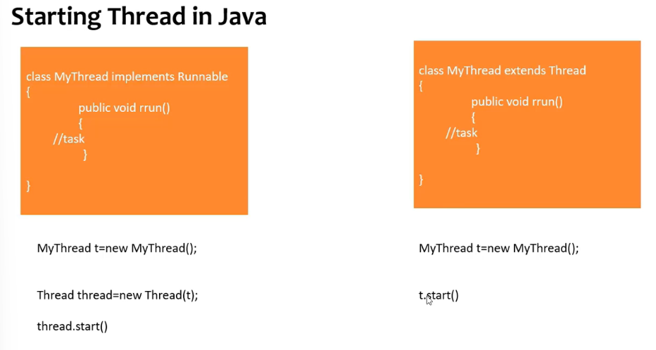

**Best** way is to use **Runnable** interface as we are implementing, we can also extend some other class. If we go with extending Thread class then no other class can be inherited.

**Main**() method is also a thread (main thread), jvm runs main thread and and then it calls other threads.

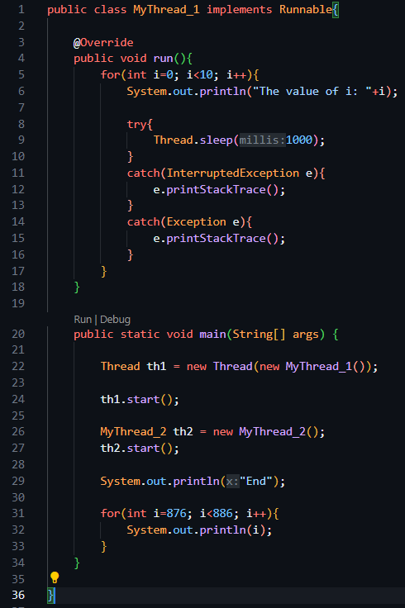

Pehle main thread execute hoga also main thread ka jo bhi statement hai other thread ke alwa wo bhi pehle execite hoga, phir threads execute honge

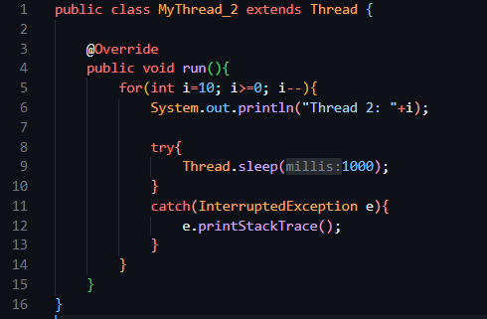

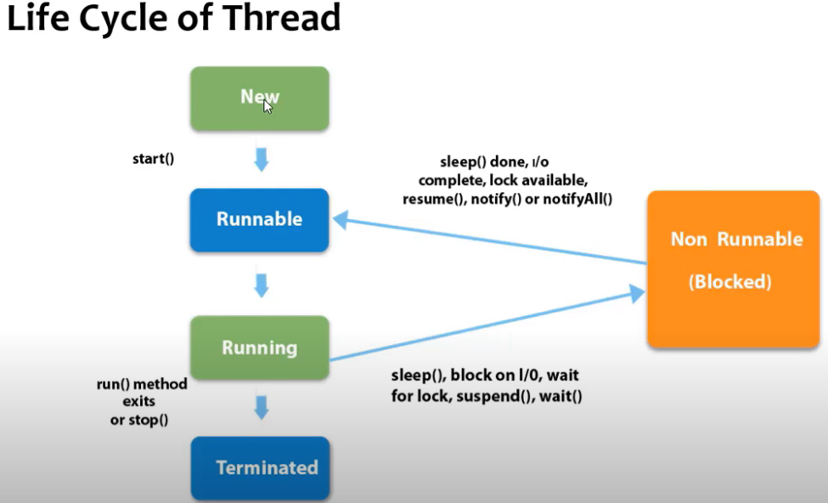

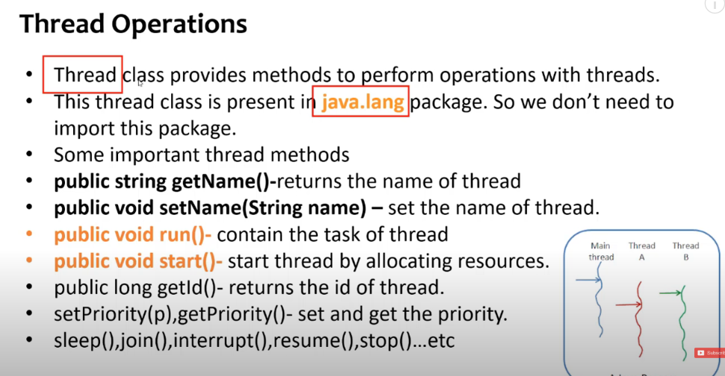

Thread Methods

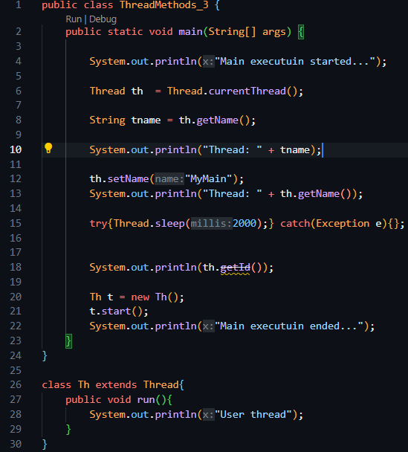

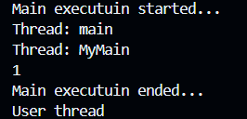

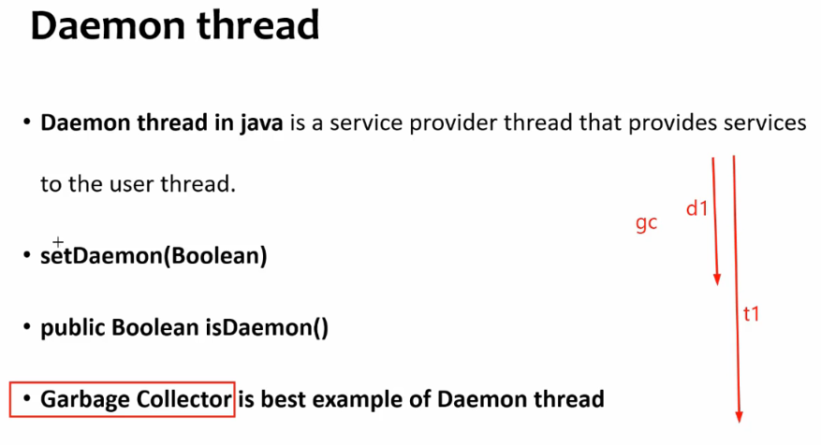

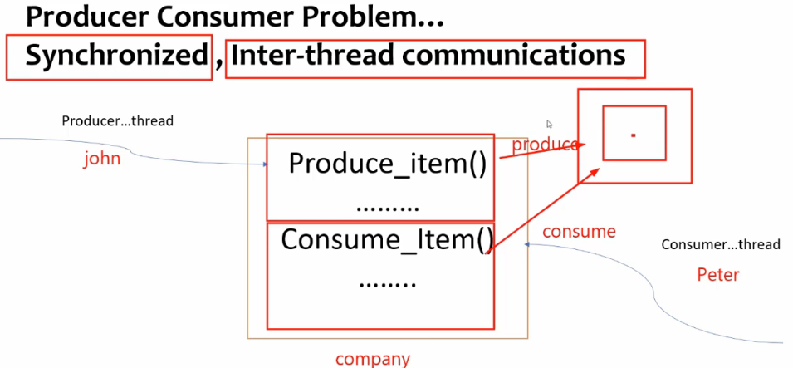

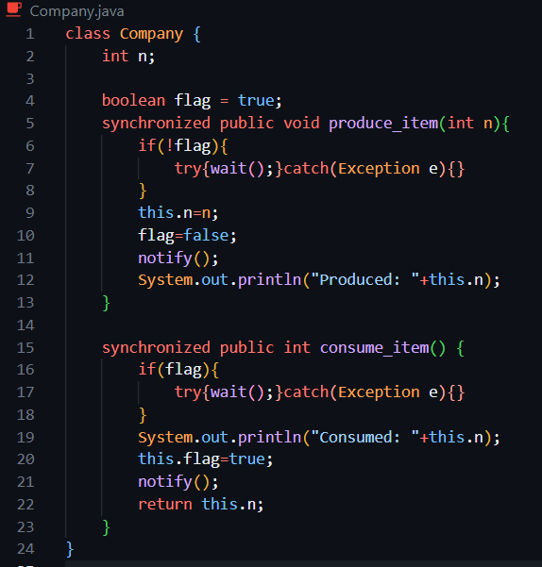

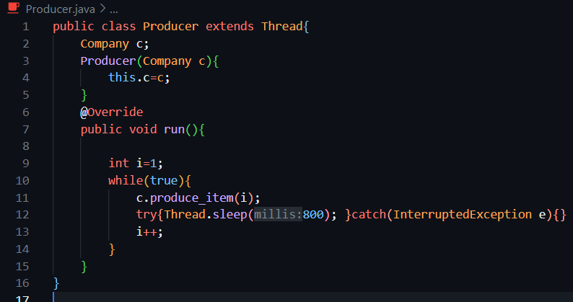

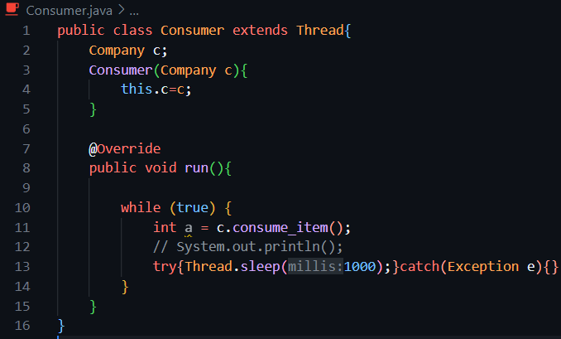

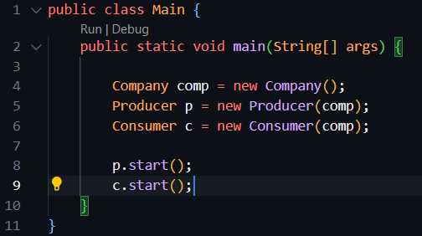

Below is a “big-picture” walk-through that ties together the things you asked about—what really happens when you start several threads from main, how the JVM maps them onto the CPU, what stacks look like, why JavaScript can be “single-threaded but concurrent,” and a few modern extras (daemon threads, thread pools, **virtual threads** in Java 21, etc.).

**1 The main method and the main thread**

* When the JVM starts it immediately creates **one user (non-daemon) thread named "main"**.  
  That thread executes your class’s static initializers and then calls public static void main(String[] args)—so yes, the statements **inside main already run *on* a thread**. ([stackoverflow.com](https://stackoverflow.com/questions/17669159/what-is-the-relation-between-the-main-method-and-main-thread-in-java?utm_source=chatgpt.com), [stackoverflow.com](https://stackoverflow.com/questions/22051031/is-java-main-method-a-thread?utm_source=chatgpt.com))

**2 Creating more threads inside main**

Thread t1 = new Thread(() -> work("A"));

Thread t2 = new Thread(() -> work("B"));

t1.start(); // hands the runnable to the JVM/OS scheduler

t2.start();

System.out.println("main continues");

* start() **returns immediately.** At that point you now have three live threads (main, t1, t2) competing for CPU time.
* **Order of prints or side-effects is nondeterministic** unless you add coordination (join(), locks, latches, etc.). The scheduler may run t2 first, let main finish first, or interleave them. The Java Memory Model guarantees only “happens-before” rules you establish explicitly—there is no implicit FIFO between threads.

**3 How the JVM maps a Java Thread to the CPU**

| **Era** | **Implementation** | **Who schedules?** |
| --- | --- | --- |
| JDK <= 1.1 (rare today) | *Green threads* (all user-space) | JVM |
| JDK 1.2 – 20 | **Native (OS) threads** | The host OS scheduler |
| JDK 21+ (Project Loom) | *Virtual* threads → multiplexed onto a small pool of carrier OS threads | JVM user-mode scheduler |

* In current hotspot builds each call to new Thread() allocates an **OS thread**, so the **OS’s pre-emptive scheduler selects which runnable thread runs on which core and for how long (time-slicing).** ([waitingforcode.com](https://www.waitingforcode.com/java-concurrency/os-thread-scheduler-java-thread/read?utm_source=chatgpt.com), [stackoverflow.com](https://stackoverflow.com/questions/2653458/understanding-javas-native-threads-and-the-jvm?utm_source=chatgpt.com))
* You can hint with setPriority, but the OS can ignore it.
* With **virtual threads** (Thread.startVirtualThread or Executors.newVirtualThreadPerTaskExecutor()), you still code against java.lang.Thread, but the JVM parks/unparks them like goroutines or Kotlin coroutines; they block *without* tying up an OS thread. ([openjdk.org](https://openjdk.org/projects/loom/?utm_source=chatgpt.com), [wiki.openjdk.org](https://wiki.openjdk.org/display/loom/Main?utm_source=chatgpt.com))

**4 Stacks, heap, and what a context-switch saves**

* **Every Java thread has its *own* call stack** (default size ~1 MB, configurable). The stack holds local variables, partial results and return addresses. ([docs.oracle.com](https://docs.oracle.com/javase/specs/jvms/se7/html/jvms-2.html?utm_source=chatgpt.com), [docs.oracle.com](https://docs.oracle.com/cd/E15289_01/JRSDK/thread_basics.htm?utm_source=chatgpt.com))
* All threads **share the heap and method area**, so coordination primitives (locks, synchronized, java.util.concurrent structures, atomics) exist to avoid data races.
* During a context switch the OS saves CPU registers + stack pointer for the pre-empted thread and loads the registers for the next runnable thread; the caches/TLB may need to refill, which is why tight thread counts matter for performance.

**5 Thread life-cycle states (quick recap)**

NEW → RUNNABLE ⇄ BLOCKED / WAITING / TIMED_WAITING → TERMINATED  
These are JVM-level states you see in Thread.getState() or a jstack dump; **only RUNNABLE threads compete for CPU.** ([docs.oracle.com](https://docs.oracle.com/javase/8/docs/api/java/lang/Thread.State.html?utm_source=chatgpt.com))

**6 Daemon vs. user threads**

* A **daemon** thread (e.g., a garbage-collector thread, or one you create via thread.setDaemon(true)) *does not* keep the JVM alive.
* The JVM exits when **all user threads terminate**, regardless of any live daemons.

**7 Why JavaScript feels different: the Event-Loop model**

| **JavaScript (browser / Node)** | **Java** |
| --- | --- |
| **One main thread** running the **call stack** | Many OS (or virtual) threads |
| **Event loop** pulls tasks from a **macrotask queue** (I/O callbacks, timers) and a **microtask queue** (Promises) and runs them *serially* | OS scheduler runs ready threads *in parallel* (on multicore) |
| Non-blocking APIs hand off work to the OS or a thread-pool (libuv in Node) and post a callback when ready | Blocking I/O stalls the calling thread unless you use NIO/async |

So JavaScript is *single-threaded by default but concurrent*: long-running I/O never blocks the event loop; instead it completes in the background and the callback is queued. The CPU still only executes **one JS frame at a time**, preventing data races inside ordinary code. ([developer.mozilla.org](https://developer.mozilla.org/en-US/docs/Web/JavaScript/Reference/Execution_model?utm_source=chatgpt.com))

Modern JS environments **can** spin up real worker threads (Web Workers, worker_threads in Node) for CPU-heavy work, but they communicate via messages, not shared memory (except SharedArrayBuffer with explicit atomics).

**8 Putting it all together—practical tips**

1. **Don’t rely on thread start order.** Use join(), CountDownLatch, or higher-level constructs if you need ordering.
2. **Prefer executors** (Executors.newFixedThreadPool, newCachedThreadPool, or in Java 21 newVirtualThreadPerTaskExecutor) instead of manual new Thread().
3. Guard shared mutable data with proper synchronization or better, design using immutable messages or concurrent collections.
4. Measure! Too many OS threads can hurt more than help; millions of *virtual* threads are cheap, but OS threads are not.
5. Use Thread.currentThread().getName() liberally when logging so you can see who actually ran.

**Number Class (Abstract Class)**

**Number class in Java** is an abstract class that is the superclass of Byte, Short, Integer, Long, Float, and Double classes.

The Byte, Short, Integer, Long, Float, and Double classes are the most commonly used wrapper classes that represent numeric values.

All the numeric type wrappers inherit from abstract class Number. Java Number class and its subclasses are present in java.lang package. It was added in Java 1.0 version.

**Number Class Declaration**

The abstract Number class extends Object class and implements Serializable interface. The general declaration of Number class is as follows:

public abstract class Number

extends Object

implements Serializable

The classes such as AtomicInteger, AtomicLong, BigDecimal, BigInteger, DoubleAccumulator, DoubleAdder, LongAccumulator, and LongAdder also implement Number class.

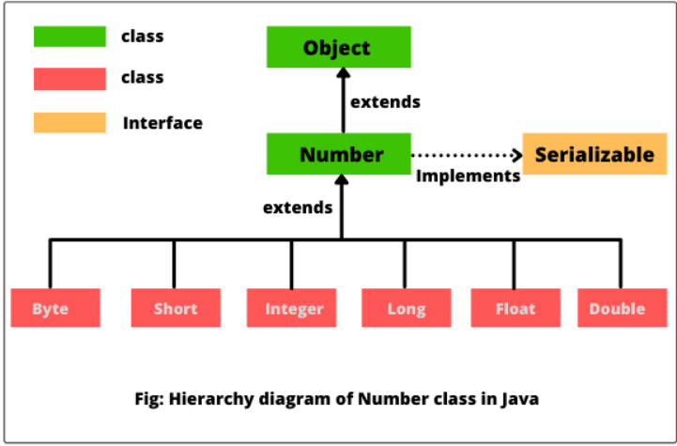

**Methods of Number Class in Java**

Number class defines some useful methods that return the value of an object in each of the different number formats. These methods are as follows:

**1. byte byteValue():** This method returns the value of an object as a byte which may involve rounding or truncation. In other words, it converts the calling object into byte value. The calling object may be an object of Byte, Short, Integer, Long, Float, or Double class.

**2. short shortValue():** This method returns the value of an object as a short which may involve rounding or truncation. In simple words, it converts the calling object into short value.

**3. abstract int intValue():** It returns the value of an object as a short which may involve rounding or truncation. That is, it converts the calling object into int value.

**4. abstract long longValue():** It returns the value of an object as long which may involve rounding or truncation. It is used to convert the calling object into long value.

**5. abstract float floatValue():** This method returns the value of an object as float which may involve rounding.

**6. abstract double doubleValue():** This method returns the value of an object as long which may involve rounding.

**Java lang Classes**:

list of **important classes from java.lang** that are commonly asked in **Java interviews, academic exams, and coding tests**, along with their **key methods and usage**.

**🔹 1. Object**

The root of all Java classes.

**Important methods:**

* equals(Object obj)
* hashCode()
* toString()
* clone()
* finalize() (deprecated)
* getClass()
* wait(), notify(), notifyAll()

➡️ **Used in:** overriding, comparison, synchronization, Object class contracts.

**🔹 2. String (Immutable)**

Handles character sequences.

**Important methods:**

* length()
* charAt(int index)
* substring(int start, int end)
* equals(), equalsIgnoreCase()
* compareTo()
* indexOf(), lastIndexOf()
* toLowerCase(), toUpperCase()
* trim(), replace(), split()
* concat(), valueOf()

➡️ **Used in:** text processing, hashing, string manipulation.

**🔹 3. StringBuilder / StringBuffer**

Mutable character sequences.

**Important methods:**

* append(), insert(), delete()
* reverse()
* toString()
* capacity(), ensureCapacity()

➡️ StringBuilder is faster (not synchronized), StringBuffer is thread-safe.

**🔹 4. Math**

Utility class for mathematical operations.

**Important methods:**

* abs(), max(), min()
* pow(), sqrt()
* ceil(), floor(), round()
* random() (returns a double between 0.0 and 1.0)

➡️ **Used in:** numerical logic, game dev, simulations.

**🔹 5. Integer, Double, etc. (Wrapper Classes)**

Converts between primitives and objects.

**Important methods:**

* parseInt(String) → returns primitive
* valueOf(String) → returns object
* intValue(), doubleValue() (for object to primitive)
* compareTo(), equals()

➡️ **Used in:** collections, autoboxing, parsing.

**🔹 6. System**

Provides access to system-related resources.

**Important methods/fields:**

* System.out.println()
* System.in (for input stream)
* System.err (for error output)
* System.currentTimeMillis(), nanoTime()
* System.gc() (suggest garbage collection)
* exit(int status)

➡️ **Used in:** I/O, performance timing, termination.

**🔹 7. Thread (and Runnable)**

For multithreading.

**Important methods:**

* start(), run()
* sleep(ms), join()
* isAlive(), getName(), setPriority()
* yield(), interrupt()
* setDaemon(true)

➡️ Use Runnable to implement threads without extending class.

**🔹 8. Exception, RuntimeException, Throwable**

Base for error handling.

**Important methods:**

* getMessage()
* printStackTrace()
* getCause()
* initCause()

➡️ Custom exceptions should extend Exception or RuntimeException.

**🔹 9. Class<T>**

Part of reflection API.

**Important methods:**

* forName(String className)
* getDeclaredMethods(), getDeclaredFields()
* newInstance() (deprecated)
* getSuperclass()

➡️ **Used in:** frameworks, ORM, dynamic loading.

**🔹 10. Runtime**

Interacts with the JVM at runtime.

**Important methods:**

* getRuntime()
* exec(String command) → run OS commands
* availableProcessors()
* freeMemory(), totalMemory(), gc()

➡️ **Used in:** resource management, monitoring, running shell commands.

**🔹 11. Enum<E extends Enum<E>>**

Superclass for enums.

**Important methods:**

* values() (returns array of enum constants)
* valueOf(String name)
* ordinal() → index of constant

➡️ Useful for creating type-safe constant sets.

**🔹 12. Number (Abstract class)**

Superclass of wrapper classes.

**Methods to override in subclasses:**

* intValue(), longValue(), floatValue(), doubleValue()

➡️ Used in generic number-based code.

**✅ Bonus: Other Mentionable Classes**

| **Class** | **Key Use** |
| --- | --- |
| Throwable | Superclass of all exceptions and errors |
| Package | Metadata about a package |
| Void | Represents the void return type |

**💡 Common Interview Questions:**

* Difference between String, StringBuilder, StringBuffer
* What is Object.equals() and how to override it properly?
* When to use == vs .equals()?
* What happens if you override hashCode() but not equals()?
* How does Thread.sleep() vs Thread.yield() work?
* How is Integer.valueOf() different from parseInt()?
* Why is String immutable?
* How do you use System.nanoTime() to measure execution time?

**1. Difference between String, StringBuilder, and StringBuffer**

* String: Immutable (cannot be changed).
* StringBuilder: Mutable and **not thread-safe** (faster).
* StringBuffer: Mutable and **thread-safe** (slower).

**2. What is Object.equals() and how to override it properly?**

* equals() checks if two objects are logically equal.
* Override it to compare field values instead of memory addresses.

@Override

public boolean equals(Object obj) {

if (this == obj) return true;

if (!(obj instanceof MyClass)) return false;

MyClass other = (MyClass) obj;

return this.id == other.id;

}

**3. When to use == vs .equals()?**

* == checks reference (memory) equality.
* .equals() checks content/logical equality.

**4. What happens if you override hashCode() but not equals()?**

* May break HashMap, HashSet, etc.
* Always override **both** to maintain consistency.

**5. How does Thread.sleep() vs Thread.yield() work?**

* sleep(ms): Pauses current thread for given milliseconds.
* yield(): Suggests to CPU that current thread can pause to let others run.

**6. How is Integer.valueOf() different from parseInt()?**

* Integer.valueOf() → returns Integer object.
* Integer.parseInt() → returns primitive int.

**7. Why is String immutable?**

* For security, thread safety, and to allow string caching (string pool).

**8. How do you use System.nanoTime() to measure execution time?**

long start = System.nanoTime();

// code to test

long end = System.nanoTime();

System.out.println("Time: " + (end - start) + " ns");

**Abstract Class**

**Abstract Classes vs Interfaces** in Java — including their **need, design, usage, differences, and practical scenarios**, along with **constructor behavior** in abstract classes.

**🔹 1. What is an Abstract Class in Java?**

An abstract class is a class that **cannot be instantiated** and may contain **abstract (unimplemented) methods** as well as **concrete (implemented) methods**.

abstract class Animal {

String name;

Animal(String name) {

this.name = name;

System.out.println("Animal constructor called");

}

abstract void makeSound(); // Abstract method

void sleep() { // Concrete method

System.out.println(name + " is sleeping...");

}

}

**🧪 2. Constructor in Abstract Class**

**✅ Yes, abstract classes can have constructors.**

* The constructor is called **when a subclass is instantiated**.
* It helps to **initialize common fields**.

class Dog extends Animal {

Dog(String name) {

super(name); // Calls constructor of abstract class

}

void makeSound() {

System.out.println(name + " says: Woof!");

}

}

**Output:**

Animal constructor called

Rex says: Woof!

**❓ 3. Why Do We Need Abstract Classes?**

* To provide a **base class** with shared code and common functionality.
* To **enforce a contract** on subclasses (must implement abstract methods).
* To allow **partial implementation** (unlike interfaces before Java 8).
* Good for **“is-a” relationships** (e.g., Dog is-an Animal).

**🔸 4. What is an Interface?**

An interface in Java defines a **contract** that classes must follow. It only contains **method signatures** (no implementation until Java 8).

interface Flyable {

void fly(); // public and abstract by default

}

From **Java 8+**, interfaces can also have:

* default methods (with body)
* static methods
* private methods (from Java 9+)

interface Flyable {

void fly();

default void glide() {

System.out.println("Gliding...");

}

static void checkWings() {

System.out.println("Wings checked.");

}

}

**❓ 5. Why Do We Need Interfaces?**

* To **achieve full abstraction** (before Java 8).
* To implement **multiple inheritance** of types.
* To define **capabilities/behaviors** (e.g., Runnable, Comparable, Serializable).

**🔁 6. Abstract Class vs Interface – Full Comparison**

| **Feature** | **Abstract Class** | **Interface** |
| --- | --- | --- |
| **Instantiation** | Cannot be instantiated | Cannot be instantiated |
| **Methods** | Can have abstract & concrete methods | Only abstract methods (till Java 7); default/static from Java 8 |
| **Constructors** | ✅ Yes | ❌ No |
| **Access Modifiers** | Any (public, protected, private) | Methods are public by default |
| **Variables** | Can have instance variables | Only public static final (constants) |
| **Multiple Inheritance** | ❌ Not supported | ✅ Supported |
| **When to Use** | Shared code + contract | Just the contract (capability) |
| **Extends / Implements** | extends | implements |
| **Default Implementation?** | ✅ Yes | From Java 8+ only |

**🧪 7. Real World Example**

**Using Abstract Class:**

abstract class Shape {

abstract double area();

void describe() {

System.out.println("This is a shape.");

}

}

**Using Interface:**

interface Drawable {

void draw();

}

**Combined:**

class Circle extends Shape implements Drawable {

double radius;

Circle(double r) {

radius = r;

}

double area() {

return Math.PI * radius * radius;

}

public void draw() {

System.out.println("Drawing a circle.");

}

}

**🔧 8. Can a Class Implement Multiple Interfaces?**

✅ Yes, this is allowed and common.

class Car implements Drivable, Flyable, Sailable { ... }

**🚫 9. Can a Class Extend Multiple Abstract Classes?**

❌ No. Java doesn’t support multiple inheritance of classes.

**🔄 10. Can an Interface Extend Another Interface?**

✅ Yes, interfaces can extend multiple other interfaces.

interface A {

void methodA();

}

interface B extends A {

void methodB();

}

**🧠 11. Interview-Focused Points**

| **Question** | **Key Answer** |
| --- | --- |
| Why abstract class if interface exists? | Abstract class allows **partial implementation** and can have constructors/fields |
| Why interface if abstract class exists? | Interfaces enable **multiple inheritance of behavior** |
| Can abstract class have final methods? | ✅ Yes, but cannot be overridden |
| Can interface have fields? | ✅ Only constants (public static final) |
| Can interface methods be private? | ✅ Yes (from Java 9+) but only inside interface |
| Can we have main() in abstract class? | ✅ Yes |
| Can we instantiate abstract class? | ❌ No |
| Can interface extend class? | ❌ No |
| Can abstract class implement interface? | ✅ Yes |

**✅ 12. Best Practices**

* Use **interface** when:
  + You want to define **capabilities** (e.g., Serializable, Cloneable).
  + You need **multiple inheritance** of types.
* Use **abstract class** when:
  + You need **shared state or code**.
  + You want to provide **default behavior and some enforced rules**.

**💬 Summary in One Line:**

Use **interface** for "what an object can do" and **abstract class** for "what an object is".

**Abstract Class (Main Method)**:

Great question!

Yes, an **abstract class in Java can have a main() method**, and it works just like in any normal class — even though **abstract classes cannot be instantiated**, they can still be **used directly to run static methods**, including main().

**✅ Why is this allowed?**

* The main() method is **static**, and **static methods belong to the class**, not to an object.
* You do **not need to create an object** to call a static method.
* Since you **don't need to instantiate** the abstract class, it's perfectly valid to have a main() method in it.

**✅ Example: Abstract Class with main() Method**

abstract class TestAbstract {

public static void main(String[] args) {

System.out.println("Main method in abstract class is running!");

}

}

**🧪 Output:**

Main method in abstract class is running!

**✅ How to run this?**

* Save it as TestAbstract.java
* Compile and run like a normal Java class:

javac TestAbstract.java

java TestAbstract

**📌 Note:**

* You **cannot** do: new TestAbstract() — because it's abstract.
* But you **can run static methods** like main() without instantiating the class.

**🤔 Use Case?**

* Rare in production, but useful for:
  + **Testing** abstract logic.
  + Running **utility methods** inside an abstract class.
  + Providing a **demo** or **runner method**.

**🧠 Summary**

| **Point** | **Explanation** |
| --- | --- |
| Can abstract class have main()? | ✅ Yes |
| Can it run? | ✅ Yes, if it's static |
| Is instantiation needed? | ❌ No |
| Why allowed? | Static methods don’t need objects |

**interfaces** in Java are not like normal (concrete) classes. Here's a **clear comparison** of what **interfaces cannot have**, compared to normal classes and abstract classes.

**✅ Summary Table: What Interfaces Cannot Have (Compared to Classes)**

| **Feature** | **Normal Class** | **Abstract Class** | **Interface** |
| --- | --- | --- | --- |
| Constructors | ✅ Yes | ✅ Yes | ❌ No |
| Instance Variables (non-static) | ✅ Yes | ✅ Yes | ❌ No |
| Instance Initializer Blocks | ✅ Yes | ✅ Yes | ❌ No |
| Object Creation | ✅ Yes | ❌ (can't instantiate) | ❌ No |
| Static Methods | ✅ Yes | ✅ Yes | ✅ Yes (Java 8+) |
| Default Methods | ❌ (only concrete) | ✅ (concrete allowed) | ✅ Yes (Java 8+) |
| Private Methods | ✅ Yes | ✅ Yes | ✅ Yes (Java 9+) |
| Final Methods | ✅ Yes | ✅ Yes | ❌ No |
| Fields with modifiers | Any access/instance | Any access/instance | Only public static final (constants) |
| main() method | ✅ Yes | ✅ Yes | ❌ No (directly not allowed) |
| Static Blocks | ✅ Yes | ✅ Yes | ✅ Yes (Java 8+) |
| Method Bodies | ✅ Yes | ✅ Yes / abstract | Only default/static/private (from Java 8/9) |
| Multiple Inheritance | ❌ No | ❌ No | ✅ Yes (of types only) |

**🚫 Key Things an Interface Cannot Have**

**1. ❌ Constructors**

* Interfaces cannot be instantiated, so **constructors don’t make sense**.

interface Test {

// Error: Constructors not allowed

Test() {}

}

**2. ❌ Instance Variables**

* Interfaces can only have **constants**, i.e., variables that are:
  + public static final

interface MyInterface {

int x = 10; // This is implicitly public static final

}

You cannot have:

int y = 5; // non-static: ❌ not allowed

**3. ❌ Main Method (Usually)**

* Interfaces **can't have main()** like classes, but...
* **You CAN have static main()** from Java 8, but it is rarely used and can't be run directly like in classes.

interface Demo {

static void main(String[] args) {

System.out.println("main() inside interface");

}

}

🛑 You cannot run java Demo from terminal like a class.

**4. ❌ Method Types**

* **No final methods** → Because methods are intended to be overridden.
* **No synchronized methods** → Interfaces only define behavior, no thread logic.

**✅ What Interfaces *Can* Have (Java 8+ and 9+)**

| **Method Type** | **Allowed?** | **Notes** |
| --- | --- | --- |
| Abstract Methods | ✅ Yes | Always allowed |
| Default Methods | ✅ Yes | Java 8+ |
| Static Methods | ✅ Yes | Java 8+ |
| Private Methods | ✅ Yes | Java 9+ only for reuse within default methods |

**📌 Summary in One Line**

Interfaces are for **defining contracts (what a class should do)**, not for holding state or complex logic like classes.

Here’s a **complete example** and explanation of an **abstract class in Java** that:

✅ Has a **constructor**  
✅ Has a **main() method**  
✅ Is used with **inheritance**

**✅ 1. Code Example: Abstract Class with Constructor, Main, and Inheritance**

abstract class Animal {

String name;

// ✅ Constructor

Animal(String name) {

this.name = name;

System.out.println("Animal constructor called");

}

// ✅ Abstract method

abstract void makeSound();

// ✅ Concrete method

void sleep() {

System.out.println(name + " is sleeping...");

}

// ✅ main() method in abstract class

public static void main(String[] args) {

// You cannot create an object of Animal directly

// Animal a = new Animal("Generic"); ❌

// But you can create a subclass object

Dog dog = new Dog("Rex");

dog.makeSound();

dog.sleep();

}

}

// ✅ Subclass that inherits and implements the abstract method

class Dog extends Animal {

Dog(String name) {

super(name); // Calls constructor of abstract class

System.out.println("Dog constructor called");

}

@Override

void makeSound() {

System.out.println(name + " says: Woof!");

}

}

**🧾 2. Output:**

Animal constructor called

Dog constructor called

Rex says: Woof!

Rex is sleeping...

**🔍 3. Breakdown**

**✅ Constructor in Abstract Class**

* It **runs when subclass is created**.
* Used to **initialize shared fields** (name here).

**✅ Inheritance**

* Dog uses extends Animal.
* It must **implement** the abstract method makeSound().

**✅ main() Method**

* Abstract class **can have a static main()**.
* You **cannot create an object** of abstract class in main() directly.
* You can create a **subclass object** to test functionality.

**✅ Key Interview Points**

| **Concept** | **Explanation** |
| --- | --- |
| Can abstract class have constructor? | ✅ Yes, used for initializing shared state |
| Can abstract class have main method? | ✅ Yes, it's static so no object needed |
| Can we create object of abstract class? | ❌ No |
| Can abstract class be inherited? | ✅ Yes |
| Must subclass implement all abstract methods? | ✅ Yes (unless it’s also abstract) |

**Method Signature**:

In Java, the method signature consists of two main parts:

* **Method Name:** This is the identifier given to the method.
* **Parameter List:** This includes the data types of the parameters in their defined order. The number of parameters and their types are crucial.

Important Note: The return type of the method and any exceptions thrown by the method are not considered part of the method signature.

The method signature is essential for method overloading, as it allows multiple methods within the same class to share the same name as long as their parameter lists differ in terms of the number of parameters or their data types.

**This & Super**

Here’s a complete, **interview-ready explanation** of this and super in Java — including their **usage, rules, differences, and practical code snippets** — tailored for both **theory** and **coding round clarity**.

**🔹 this Keyword in Java**

this refers to the **current object** of the class — i.e., the instance on which a method or constructor is being invoked.

**✅ Common Use Cases of this**

| **Use Case** | **Example** | **Purpose** |
| --- | --- | --- |
| 1. Distinguishing instance variables from parameters | this.name = name; | Avoid name conflict |
| 2. Calling another constructor in same class | this(...) | Constructor chaining |
| 3. Referring current object as argument | method(this); | Passing current object |
| 4. Returning current object | return this; | For method chaining |
| 5. Accessing current object’s fields or methods | this.var, this.method() | Explicit reference |

**🔧 Code Examples for this**

**🟢 1. Distinguishing Instance Variables**

class Student {

String name;

Student(String name) {

this.name = name; // 'this' distinguishes between instance and parameter

}

}

**🟢 2. Calling Another Constructor (this())**

class Box {

int width, height;

Box() {

this(10, 20); // calls parameterized constructor

}

Box(int w, int h) {

this.width = w;

this.height = h;

}

}

**🟢 3. Passing Current Object**

class Test {

void show(Test obj) {

System.out.println("Inside show");

}

void call() {

show(this); // passes current object

}

}

**🟢 4. Method Chaining using this**

class Person {

String name;

Person setName(String name) {

this.name = name;

return this;

}

void display() {

System.out.println("Name: " + name);

}

}

new Person().setName("Arbaz").display();

**🔸 super Keyword in Java**

super refers to the **immediate parent class** (superclass) of the current object.

**✅ Common Use Cases of super**

| **Use Case** | **Example** | **Purpose** |
| --- | --- | --- |
| 1. Accessing parent class constructor | super(...) | Constructor chaining to parent |
| 2. Accessing parent class methods | super.method() | Call overridden methods |
| 3. Accessing parent class fields | super.var | Resolve name conflict |

**🔧 Code Examples for super**

**🟡 1. Calling Parent Constructor (super())**

class Animal {

Animal(String name) {

System.out.println("Animal: " + name);

}

}

class Dog extends Animal {

Dog() {

super("Dog"); // calls parent class constructor

}

}

**🟡 2. Accessing Overridden Method**

class Parent {

void greet() {

System.out.println("Hello from Parent");

}

}

class Child extends Parent {

void greet() {

super.greet(); // calls Parent’s method

System.out.println("Hello from Child");

}

}

**🟡 3. Accessing Parent Class Variable**

class Vehicle {

int speed = 100;

}

class Car extends Vehicle {

int speed = 120;

void display() {

System.out.println("Child speed: " + speed);

System.out.println("Parent speed: " + super.speed);

}

}

**⚔️ Difference Between this and super**

| **Feature** | **this** | **super** |
| --- | --- | --- |
| Refers to | Current class object | Parent class object |
| Accesses | Current class members | Parent class members |
| Used in constructors | Calls another constructor in same class (this()) | Calls superclass constructor (super()) |
| Refers to fields/methods | In current class | In parent class |
| Can be used in static context? | ❌ No | ❌ No |

**🚫 Common Interview Pitfalls**

| **Question** | **Clarification** |
| --- | --- |
| Can this() and super() be used together? | ❌ No — they must be **first statement** in constructor |
| Can we call super.super? | ❌ No — not allowed in Java |
| Can this be used in static methods? | ❌ No — static methods don’t belong to any object |
| Can super be used in a static method? | ❌ No — same reason as above |

**✅ Best Practice Tip**

* Use this() to reduce constructor duplication.
* Use super() carefully when subclassing to ensure proper initialization.

**🎯 Interview-Focused Summary**

| **What to Know** | **Why It’s Important** |
| --- | --- |
| this() vs super() constructor calls | Understand initialization flow |
| this.var vs var | Resolve variable shadowing |
| Overridden methods with super.method() | To retain parent behavior |
| Static context rules | Prevent compile-time errors |
| Method chaining with this | Useful in builder patterns, fluent APIs |

**✅ Simple Explanation: Constructor Chaining using this in Java**

**Constructor chaining using this()** means one constructor **calls another constructor in the same class** to **avoid code duplication** and make the code **clean and organized**.

**🧠 Why use it?**

* To reuse constructor logic.
* To initialize common fields from one place.
* To reduce repeated code.

**🧪 Example:**

class Student {

String name;

int age;

// Constructor 1: Default

Student() {

this("Unknown", 0); // calls Constructor 2

}

// Constructor 2: One parameter

Student(String name) {

this(name, 0); // calls Constructor 3

}

// Constructor 3: Two parameters

Student(String name, int age) {

this.name = name;

this.age = age;

}

void show() {

System.out.println(name + " - " + age);

}

public static void main(String[] args) {

Student s1 = new Student();

Student s2 = new Student("Arbaz");

Student s3 = new Student("Ali", 21);

s1.show(); // Unknown - 0

s2.show(); // Arbaz - 0

s3.show(); // Ali - 21

}

}

**🔗 Rules of this() chaining:**

1. this() must be the **first statement** in the constructor.
2. You can chain multiple constructors.
3. Helps follow **DRY** principle (Don't Repeat Yourself).

**🔁 In Simple Words:**

Constructor chaining with this() is like saying:

“Hey, this constructor already knows how to set this up, let’s just call it and reuse that logic!”

**Equals And Hashcode And the Contract between them**

Great — this is a **very important Java core concept**, especially for interviews and understanding **hash-based data structures** like HashMap, HashSet, and Hashtable.

**🔍 1. What is equals() in Java?**

* Defined in java.lang.Object.
* Compares two objects for **logical equality**.
* **Default implementation** in Object compares **memory addresses** (==).
* You **override** it to compare field values (e.g., name, id, etc.).

public boolean equals(Object obj) {

if (this == obj) return true; // same reference

if (obj == null || getClass() != obj.getClass()) return false;

MyClass other = (MyClass) obj;

return this.id == other.id;

}

**🧮 2. What is hashCode()?**

* Also from java.lang.Object.
* Returns an **integer hash code** for an object.
* Used in **hash-based collections** to determine **bucket location**.
* If equals() says two objects are equal, then **hashCode() must return the same value**.

@Override

public int hashCode() {

return Objects.hash(id); // or return id;

}

**⚠️ 3. Contract Between equals() and hashCode()**

| **Rule** | **Explanation** |
| --- | --- |
| 1. Equal objects must have equal hash codes | a.equals(b) → a.hashCode() == b.hashCode() |
| 2. Unequal objects can have same hash code | Collisions are allowed, but should be rare |
| 3. If hashCode() not overridden, default is from Object class (memory-based) |  |

**✅ 4. Why Override Both?**

When you use objects as **keys in HashMap** or store in a **HashSet**, Java uses:

1. hashCode() → to find the **bucket**
2. equals() → to check **actual equality**

🔸 If hashCode() is wrong, it may land in the wrong bucket  
🔸 If equals() is wrong, duplicates may be allowed

**🧪 5. Practical Example (Without Override)**

class Employee {

int id;

String name;

Employee(int id, String name) {

this.id = id;

this.name = name;

}

}

HashSet<Employee> set = new HashSet<>();

set.add(new Employee(1, "John"));

set.add(new Employee(1, "John"));

System.out.println(set.size()); // ➤ Output: 2 (wrong!)

Even though logically same, without equals() and hashCode() overridden, Java treats them as different.

**✅ 6. Now with equals() and hashCode() Overridden**

@Override

public boolean equals(Object obj) {

if (this == obj) return true;

if (!(obj instanceof Employee)) return false;

Employee other = (Employee) obj;

return id == other.id && name.equals(other.name);

}

@Override

public int hashCode() {

return Objects.hash(id, name);

}

Now:

HashSet<Employee> set = new HashSet<>();

set.add(new Employee(1, "John"));

set.add(new Employee(1, "John"));

System.out.println(set.size()); // ➤ Output: 1 (correct)

**🔄 7. How Hash-Based Collections Use It**

**HashMap<K, V> internally:**

1. Calls hashCode() on key → finds the bucket.
2. Checks that bucket:
   * If key not found → insert new.
   * If key found via equals() → replace value.

**HashSet<T>:**

* Uses a HashMap<T, Object> internally.
* Only stores one copy per equals() + hashCode() rule.

**🧠 8. Real-World Use Case**

Say you create a Student class:

class Student {

int rollNo;

String name;

// equals() and hashCode() overridden based on rollNo

}

You want:

* HashMap<Student, Grade>
* HashSet<Student> to avoid duplicates

If you don’t override equals() and hashCode(), the map will treat every Student object as unique — even if the roll number is the same.

**🔐 9. Best Practice**

* Always override **both** together.
* Use **Objects.hash(...)** to simplify hashCode.
* Use **only immutable fields** in these methods (like id, not age that might change).
* Avoid mutable keys in hash collections.

**🧪 10. Test Yourself: Sample Scenario**

**Question:** You override equals() but not hashCode() in a class used as a key in a HashMap. What can go wrong?

**Answer:** The map may not find the key during lookup because it ends up in the wrong bucket. Even if two objects are equal via equals(), the hashCode() mismatch means they land in different buckets.

**Casting, Upcasting, DownCasting, Boxing, Unboxing, Auto Boxing, Auto Unboxing**

Here’s a **clear and complete explanation** of the important type conversion concepts in Java — tailored for both **conceptual clarity** and **Java interviews**:

**🔁 1. Casting**

**🔹 What is Casting?**

**Casting** is converting a variable from one type to another — either manually or automatically.

There are two types:

* **Primitive casting** (e.g., int → double)
* **Object casting** (class type conversions, like subclass ↔ superclass)

**🔼 2. Upcasting (Widening Object Conversion)**

**✅ Definition:**

Upcasting means converting a **child class object** to a **parent class reference**.

class Animal {}

class Dog extends Animal {}

Animal a = new Dog(); // ✅ Upcasting

**✅ Characteristics:**

* Happens **implicitly**
* **Safe** — no data loss
* Used in **polymorphism**

**🔽 3. Downcasting (Narrowing Object Conversion)**

**✅ Definition:**

Downcasting means converting a **parent class reference** to a **child class reference**.

Animal a = new Dog();

Dog d = (Dog) a; // ✅ Downcasting (needs explicit cast)

**⚠️ Important:**

* Must be done **manually** using (ChildClass)
* **Unsafe** if the object is not actually of child type — may throw ClassCastException

Animal a = new Animal();

Dog d = (Dog) a; // ❌ Runtime error if a is not a Dog

**🔢 4. Primitive Type Casting**

**✅ Widening (Safe & Automatic)**

int x = 10;

double d = x; // int → double (OK)

**🔽 Narrowing (Manual & Risky)**

double d = 10.5;

int x = (int) d; // double → int (manual, truncates to 10)

**📦 5. Boxing**

**✅ Definition:**

**Boxing** is converting a **primitive** into its corresponding **wrapper object** manually.

int x = 10;

Integer boxed = Integer.valueOf(x); // Boxing

**🔓 6. Unboxing**

**✅ Definition:**

**Unboxing** is converting a **wrapper object** back to its **primitive type** manually.

Integer num = Integer.valueOf(5);

int x = num.intValue(); // Unboxing

**🤖 7. Autoboxing**

**✅ Definition:**

**Autoboxing** is the **automatic** conversion of primitive → wrapper object.

int x = 7;

Integer num = x; // Autoboxing

* Happens automatically in expressions, collections, etc.

**🔄 8. Auto-unboxing**

**✅ Definition:**

**Auto-unboxing** is the **automatic** conversion of wrapper → primitive.

Integer num = 10;

int x = num; // Auto-unboxing

**📊 Summary Table**

| **Concept** | **Converts From** | **Converts To** | **Manual/Auto** | **Example** |
| --- | --- | --- | --- | --- |
| Upcasting | Child class | Parent class | Auto | Animal a = new Dog(); |
| Downcasting | Parent class | Child class | Manual | Dog d = (Dog) a; |
| Boxing | Primitive | Wrapper class | Manual | Integer x = Integer.valueOf(5); |
| Unboxing | Wrapper class | Primitive | Manual | int y = x.intValue(); |
| Autoboxing | Primitive | Wrapper class | Auto | Integer x = 5; |
| Auto-unboxing | Wrapper class | Primitive | Auto | int y = x; |

**🚫 Common Interview Pitfalls**

| **Question** | **Mistake** |
| --- | --- |
| Is Integer x = new Integer(5); autoboxing? | ❌ No — this is **manual boxing** |
| Is downcasting safe? | ❌ Only if you’re **sure** of object type |
| Can autoboxing cause null pointer? | ✅ Yes — on auto-unboxing from a null object |

Integer x = null;

int y = x; // ❌ NullPointerException

**Abstract class implementing an Interface**

Yes! In Java, an **abstract class can implement an interface**, and it **does not have to implement all the methods** of that interface — as long as it declares itself as **abstract**.

**✅ Summary Answer**

| **Question** | **Answer** |
| --- | --- |
| Can an abstract class implement an interface? | ✅ **Yes** |
| Does it need to implement all methods? | ❌ **No**, it can leave them unimplemented |
| What happens to unimplemented methods? | They must be declared **abstract**, or inherited |
| Can it define some and leave others? | ✅ **Yes** |

**📘 Example 1: Abstract Class Partially Implements Interface**

interface Animal {

void eat();

void sleep();

}

abstract class Dog implements Animal {

public void eat() {

System.out.println("Dog eats");

}

// `sleep()` is not implemented, so Dog must be abstract

}

✅ Dog implements eat(), but skips sleep() → must be abstract.

**✅ Next Step: Concrete Class Must Finish It**

class Puppy extends Dog {

public void sleep() {

System.out.println("Puppy sleeps");

}

}

Now Puppy provides the missing method sleep().

**🧠 Key Interview Points**

| **Concept** | **Explanation** |
| --- | --- |
| Abstract class can implement interfaces | ✅ Yes |
| If methods not implemented? | Class must be marked abstract |
| Can partially implement | ✅ Yes — useful for code reuse |
| Interface methods are public abstract | So overriding methods must be public |
| Multiple interfaces | An abstract class can implement **multiple interfaces** |

**❗ Be Careful**

If you **don’t** implement all interface methods and **don’t mark the class as abstract**, it causes a **compiler error**:

class Dog implements Animal { // ❌ Error if sleep() not implemented

public void eat() { }

}

**✅ Real-Life Use Case**

Abstract classes often provide **partial implementation** of an interface, and subclasses finish the rest.

abstract class AbstractList implements List {

public void add(Object o) {

// some default logic

}

// other methods left for concrete subclasses

}

**Static Nested Class**

In **Java**, a **static nested class can be inherited**, just like any regular class — because it's **just a static member class**, and not tied to an instance of the outer class.

**✅ Recap: What is a Static Nested Class?**

A **static nested class** is a class **defined inside another class**, and marked as static.  
It behaves like a **top-level class with a namespaced name**, not tied to an outer class instance.

class Outer {

static class Nested {

void greet() {

System.out.println("Hello from Nested");

}

}

}

**✅ Can it be Inherited?**

Yes.

**🔹 You can extend it from outside the outer class:**

class Child extends Outer.Nested {

void greetMore() {

System.out.println("Hello from Child");

}

}

**🔹 Using it in main:**

public class Main {

public static void main(String[] args) {

Child obj = new Child();

obj.greet(); // from Outer.Nested

obj.greetMore(); // from Child

}

}

✅ **Works perfectly** — because Outer.Nested is static, so it can be accessed without an instance of Outer.

**🚫 Rules to Remember**

| **Rule** | **Explanation** |
| --- | --- |
| Static nested class behaves like top-level class | It can be inherited, instantiated, passed around |
| It cannot access non-static members of outer class directly | Because it's static |
| Can be extended from any package if it's public | Visibility applies as usual |

**🔁 Summary**

| **Feature** | **Static Nested Class** |
| --- | --- |
| Can be inherited? | ✅ Yes |
| Needs outer class object to access? | ❌ No |
| Can access outer class members? | ❌ Only static members |
| Inherited like normal class? | ✅ Yes, with Outer.Nested syntax |

Yes, in **Java**, a **static nested class can be inherited** even **within the same outer class** where it is defined.

Yes, a static nested class can be **extended (inherited)** by another static nested class **inside the same outer class**.

**📘 Example**

public class Outer {

// 🔹 Parent static nested class

static class Parent {

void show() {

System.out.println("Inside Parent");

}

}

// 🔹 Child static nested class inheriting Parent

static class Child extends Parent {

void display() {

System.out.println("Inside Child");

}

}

public static void main(String[] args) {

Child obj = new Child();

obj.show(); // inherited from Parent

obj.display(); // own method

}

}

**✅ Output:**

Inside Parent

Inside Child

**💡 Explanation:**

| **Concept** | **Explanation** |
| --- | --- |
| Parent and Child | Both are static nested classes inside Outer |
| Child extends Parent | Works like normal inheritance |
| Outer.Child has full access to Parent | Because both are static and in the same outer class |
| Can access via Outer.Child obj = new Outer.Child(); | Or directly in same class |

**🚫 If it were non-static:**

You **cannot** extend a **non-static nested class (inner class)** from another inner class **unless it’s done in an instance context**, because inner classes require an instance of the outer class.

**✅ Summary**

| **Question** | **Answer** |
| --- | --- |
| Can static nested class be inherited within same outer class? | ✅ Yes |
| Is syntax different from regular inheritance? | ❌ No, use extends as usual |
| Can it access outer class instance members? | ❌ No, only static members of outer |
| Is object creation normal? | ✅ Yes, via new Outer.Child() |

**✅ First, Understand: What is a Static Nested Class?**

A **static nested class** is a class **defined inside another class** using the static keyword.

class Outer {

static class Inner {

void hello() {

System.out.println("Hello from Inner");

}

}

}

Unlike a non-static (inner) class, a static nested class:

* **Does NOT need an instance of the outer class** to be created.
* Is like a **top-level class**, but namespaced under the outer class.

**🧠 Misconception:**

"If it's static, how can we create an object using new Child()?"

**✅ Reality:**

The static keyword **applies to the class being nested**, not to **its instances**.

So, **you CAN create objects** of a static nested class using new, just like any other class — as long as:

* You're inside the same outer class, **or**
* You use the fully qualified name.

**✅ Example 1: Object creation inside the same outer class**

class Outer {

static class Child {

void greet() {

System.out.println("Hi from Child");

}

}

public static void main(String[] args) {

Child obj = new Child(); // ✅ Valid

obj.greet();

}

}

**✔ Output:**

Hi from Child

**✅ Example 2: Object creation from outside**

public class Test {

public static void main(String[] args) {

Outer.Child obj = new Outer.Child(); // ✅ Valid

obj.greet();

}

}

**📌 How to Access Static Members (Fields/Methods)?**

When you want to access **static methods or fields** of a static nested class:

class Outer {

static class Utility {

static void print() {

System.out.println("Static method called");

}

}

public static void main(String[] args) {

Utility.print(); // ✅ if in same outer class

Outer.Utility.print(); // ✅ from outside

}

}

**🧾 Summary Table**

| **Feature** | **Static Nested Class** |
| --- | --- |
| Can create object with new? | ✅ Yes |
| Needs outer class instance? | ❌ No |
| How to access static members? | Outer.NestedClass.method() |
| Is it like a static method? | ❌ No — static only means it's not tied to outer instance |

**✅ Final Note:**

static means: **no reference to the outer class's instance is needed**.  
It **does NOT mean** the class itself can’t have objects. You absolutely can do:  
new Outer.Inner() or simply new Inner() if you're inside the same outer class.

**Exception Handling and If-Else block**

**✅ Why Use Exception Handling in Java if We Can Use if-else?**

**🧠 Short Answer (Interview One-liner):**

"if-else is for **expected conditions**; **exception handling** is for **unexpected errors** that disrupt normal program flow."

**🔍 In-Depth Explanation**

**🔸 1. Different Purpose:**

| **Concept** | **if-else** | **try-catch (Exception Handling)** |
| --- | --- | --- |
| Use Case | Handling expected, known logic | Handling unexpected, abnormal situations |
| Flow Control | Controlled, predictable paths | Recovery from unexpected events |
| Checked at | Compile time (logic-wise) | Runtime (errors thrown by JVM or APIs) |

**🔹 2. You Cannot Handle Some Things with if-else**

int a = Integer.parseInt("abc"); // throws NumberFormatException

* You **cannot check** with if-else whether "abc" can be parsed unless you use complex parsing logic.
* But using try-catch:

try {

int a = Integer.parseInt("abc");

} catch (NumberFormatException e) {

System.out.println("Invalid number format");

}

✅ Much cleaner and safer.

**🔸 3. Separation of Normal and Error Logic**

Using exception handling:

try {

file.read();

} catch (IOException e) {

System.out.println("Error reading file");

}

Keeps normal code **separate from error-handling code** — improving **readability and maintainability**.

Using if-else to check file state manually makes code more complex and error-prone.

**🔸 4. Cleaner Stack Traces and Debugging**

* Exceptions automatically provide **stack traces** and **error messages**.
* if-else doesn't log or trace anything unless you do it manually.

**🔸 5. Checked Exceptions Cannot Be Handled with if-else Alone**

For example:

FileReader reader = new FileReader("file.txt"); // throws FileNotFoundException

* This is a **checked exception** — you **must** use try-catch or throws clause.
* if-else won’t even compile here.

**🚫 If You Use if-else Only...**

You’ll end up with:

* Messy logic
* Repetitive error checks
* Poor debugging capabilities
* Missed handling of runtime/checked exceptions (e.g., nulls, files, sockets)

**✅ Best Practice: Use Both Together**

* Use if-else for **business logic conditions** (e.g., if age > 18)
* Use try-catch for **error recovery and unexpected failures** (e.g., FileNotFoundException, SQLException, etc.)

**📘 Real-life Analogy**

| **Scenario** | **Action** |
| --- | --- |
| Checking if light is on | if light == on |
| Power goes out suddenly | try-catch fallback generator |

**🎯 Interview Keywords to Mention:**

✅ **Abnormal termination**,  
✅ **Graceful recovery**,  
✅ **Separation of concerns**,  
✅ **Cleaner code**,  
✅ **Checked vs unchecked**,  
✅ **Logging and debugging**,  
✅ **Robust and fault-tolerant systems**

**📌 Conclusion**

"if-else handles **what we expect**.  
try-catch handles **what we can't predict but must recover from**."

Using both smartly makes your code **robust, maintainable, and production-ready**.

**Current Time**

**Here are the primary ways to get the current time: [**[**1**](https://www.naukri.com/code360/library/java-current-date-and-time)**]**

* LocalTime.now(): This method returns the current time without any date or time zone information. It represents a time of day, such as 10:30:45.123.

|  |
| --- |
| import java.time.LocalTime;   public class CurrentTimeExample {  public static void main(String[] args) {  LocalTime currentTime = LocalTime.now();  System.out.println("Current LocalTime: " + currentTime);  }  } |

* LocalDateTime.now(): This method returns the current date and time without time zone information. It combines both date and time components, for example, 2025-07-12T01:02:03.456. [[1](https://www.naukri.com/code360/library/java-current-date-and-time), [2](https://sentry.io/answers/how-do-i-get-the-current-date-and-time-in-java/)]

|  |
| --- |
| import java.time.LocalDateTime;   public class CurrentTimeExample {  public static void main(String[] args) {  LocalDateTime currentDateTime = LocalDateTime.now();  System.out.println("Current LocalDateTime: " + currentDateTime);  }  } |

* ZonedDateTime.now(): This method returns the current date and time with time zone information. It provides a complete representation of a point in time, including the time zone offset. [[1](https://www.naukri.com/code360/library/java-current-date-and-time), [2](https://sentry.io/answers/how-do-i-get-the-current-date-and-time-in-java/)]

|  |
| --- |
| import java.time.ZonedDateTime;   public class CurrentTimeExample {  public static void main(String[] args) {  ZonedDateTime currentZonedDateTime = ZonedDateTime.now();  System.out.println("Current ZonedDateTime: " + currentZonedDateTime);  }  } |

* Instant.now(): This method returns the current moment in GMT/UTC time. It represents a point on the timeline, often used for timestamps.

|  |
| --- |
| import java.time.Instant;   public class CurrentTimeExample {  public static void main(String[] args) {  Instant currentInstant = Instant.now();  System.out.println("Current Instant (GMT/UTC): " + currentInstant);  }  } |

For obtaining the current time in milliseconds since the Unix epoch (January 1, 1970, 00:00:00 GMT), you can use System.currentTimeMillis(). This method returns a long value. [[3](https://www.baeldung.com/current-date-time-and-timestamp-in-java-8)]

|  |
| --- |
| public class CurrentTimeMillisExample {  public static void main(String[] args) {  long milliseconds = System.currentTimeMillis();  System.out.println("Current time in milliseconds: " + milliseconds);  } } |

**Enum**

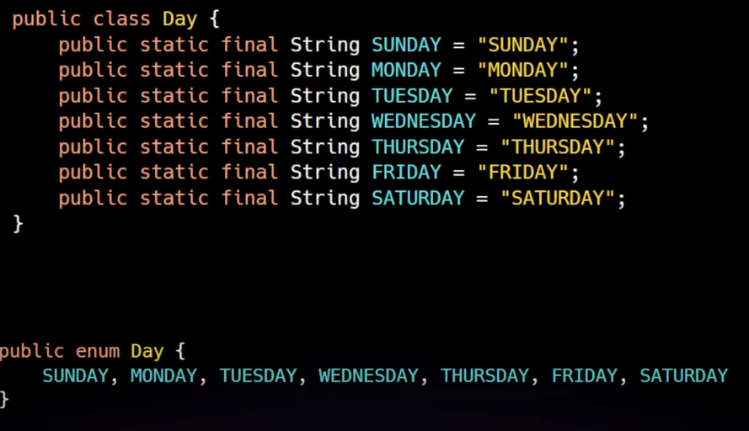

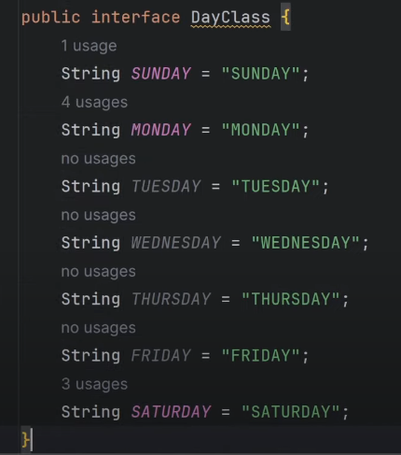

In this case enum preferred over normal class and interface.

The enum is compiled like below:

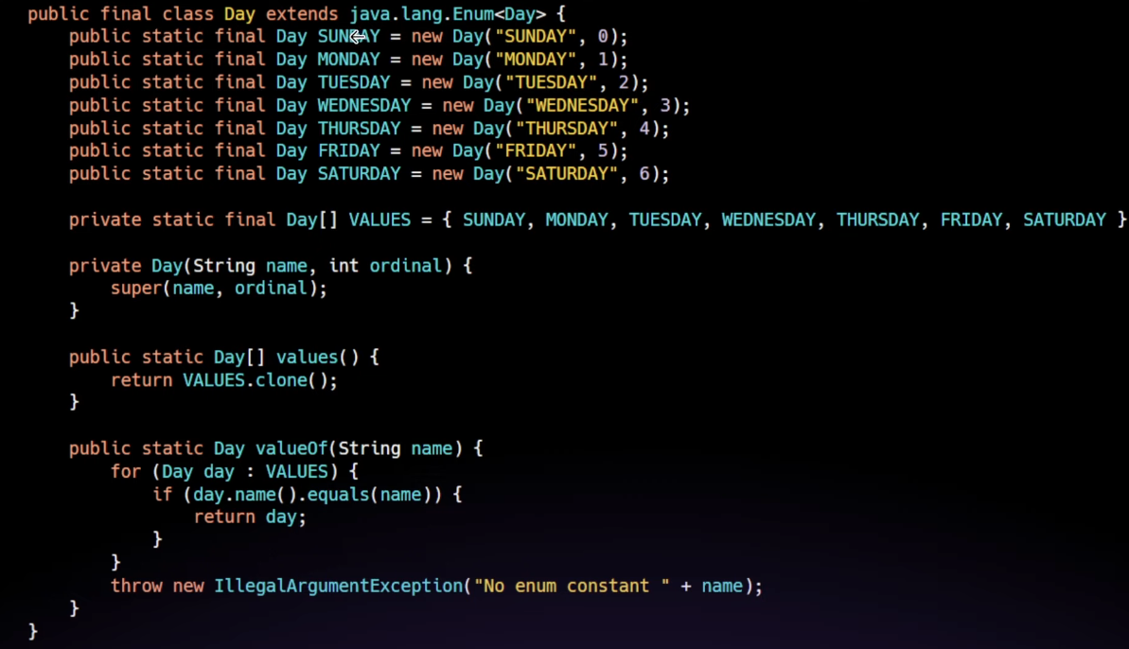

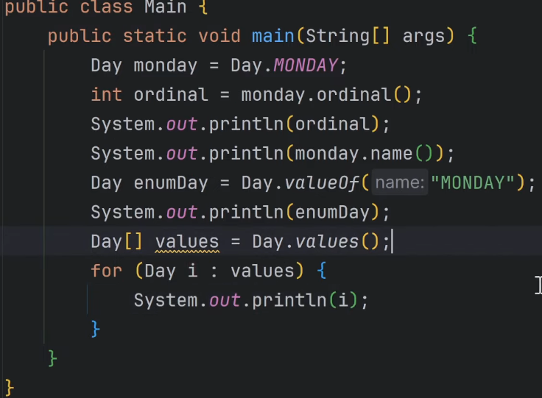

Enums constants should be very first line in the enum class, Enums get converted to class during compile time.

Other fields and methods can also be added to the enums after constants declaration.

**Generics**

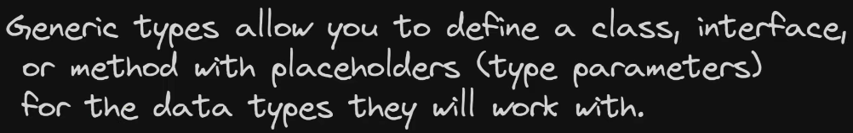

Issues before Generics

All treated as Object type, Manual typecasting and not type safe.



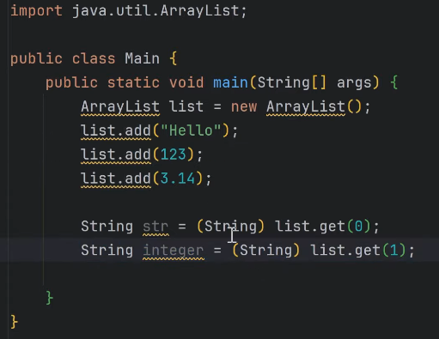

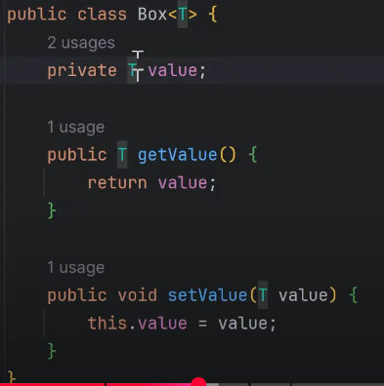

Generic Interface

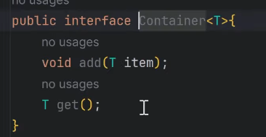

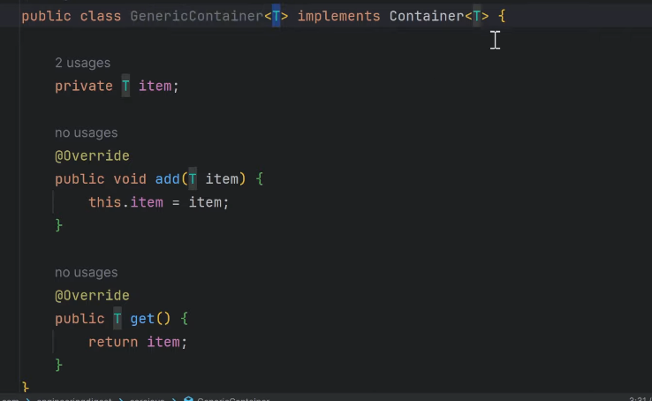

Bounded type parameters generic

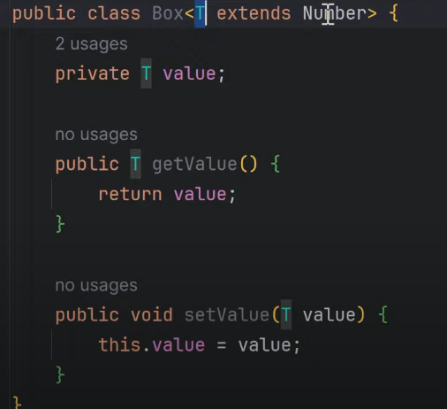

Generic Constructor

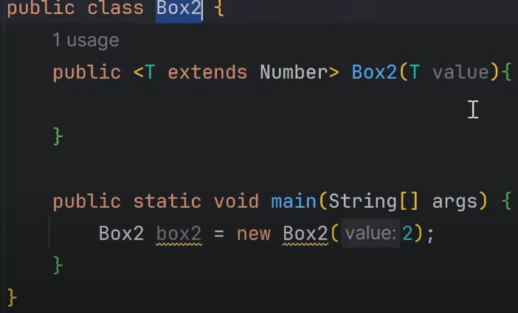

**Refelection**

**🔹 What is Reflection in Java?**

**Reflection** is a feature in Java that allows you to **inspect and modify** classes, methods, fields, and constructors **at runtime**, even if you don’t know them at compile time.

**🔸 Why is it useful?**

* For building **frameworks** (like Spring, Hibernate)
* **Unit testing tools** (like JUnit, Mockito)
* Accessing **private fields or methods**
* **Serialization/deserialization** (e.g., JSON libraries)
* **Plugin systems**, **dynamic loading**, and more

**🔹 Key Reflection Classes (from java.lang.reflect)**

| **Purpose** | **Class** |
| --- | --- |
| Get class info | Class<?> |
| Fields | Field |
| Methods | Method |
| Constructors | Constructor |
| Arrays | Array |
| Modifiers | Modifier |

**🔹 Basic Example: Inspecting Class at Runtime**

public class Person {

private String name;

public int age;

public Person() {}

public void greet() {

System.out.println("Hello!");

}

}

public class ReflectionDemo {

public static void main(String[] args) throws Exception {

Class<?> clazz = Class.forName("Person");

System.out.println("Class Name: " + clazz.getName());

System.out.println("\nFields:");

for (Field field : clazz.getDeclaredFields()) {

System.out.println("- " + field.getName());

}

System.out.println("\nMethods:");

for (Method method : clazz.getDeclaredMethods()) {

System.out.println("- " + method.getName());

}

System.out.println("\nConstructors:");

for (Constructor<?> constructor : clazz.getDeclaredConstructors()) {

System.out.println("- " + constructor);

}

}

}

**🔹 Accessing Private Fields (via Reflection)**

public class Person {

private String name = "Arbaaz";

}

import java.lang.reflect.Field;

public class AccessPrivate {

public static void main(String[] args) throws Exception {

Person p = new Person();

Field field = p.getClass().getDeclaredField("name");

field.setAccessible(true); // 🔓 bypass private

String nameValue = (String) field.get(p);

System.out.println("Private field value: " + nameValue);

}

}

**🔹 Dynamically Invoking Methods**

public class Hello {

public void sayHello(String name) {

System.out.println("Hello, " + name + "!");

}

}

public class InvokeMethod {

public static void main(String[] args) throws Exception {

Hello h = new Hello();

Method method = h.getClass().getMethod("sayHello", String.class);

method.invoke(h, "Arbaaz");

}

}

**🔹 Creating Objects with Reflection**

Constructor<Person> constructor = Person.class.getConstructor();

Person person = constructor.newInstance();

**🔸 Interview-Level Concepts & Questions**

**✅ Common Questions:**

1. **What is reflection in Java and where is it used?**
   * Reflection is used to inspect or modify classes, methods, fields, and constructors at runtime. Common in frameworks like Spring and Hibernate.
2. **How do you access private fields or methods using reflection?**
   * Use setAccessible(true) to bypass access checks.
3. **What is Class.forName() used for?**
   * It loads a class by name at runtime, returns a Class<?> object.
4. **Difference between getDeclaredMethods() vs getMethods()?**
   * getDeclaredMethods() → All methods declared in the class (even private)
   * getMethods() → Only public methods, including inherited ones
5. **Is reflection slow?**
   * Yes, compared to direct access. Avoid excessive use in performance-critical code.
6. **Can reflection break encapsulation?**
   * Yes. By accessing private fields/methods, you break the OOP principle of encapsulation.
7. **Is reflection type-safe?**
   * No. Since everything is accessed dynamically, errors may appear only at runtime.

**🧠 Pro Tip for Interviews:**

Always mention that while **reflection is powerful**, it should be used **carefully**:

* It can **violate encapsulation**
* **Slower** than normal access
* Can lead to **security risks** if not handled properly

**✅ Summary Table**

| **Feature** | **Reflection Code Example** |
| --- | --- |
| Load class at runtime | Class<?> c = Class.forName("MyClass"); |
| Access fields | Field f = c.getDeclaredField("field"); |
| Modify private field | f.setAccessible(true); f.set(obj, value); |
| Invoke method | Method m = c.getMethod("method", ...); |
| Create object | Constructor<?> con = c.getConstructor(); |

**Objects Class**

**🔷 What is Objects class in Java?**

* Objects is a **utility class** introduced in **Java 7** in the java.util package.
* It provides **static helper methods** for operating on objects — mainly for **null-safety**, **comparison**, and **hash code generation**.

import java.util.Objects;

**✅ Commonly Used Objects Methods**

|  |  |
| --- | --- |
| **Method** | **Description** |
| Objects.equals(a, b) | Safely checks equality, handles nulls. |
| Objects.hash(a, b, ...) | Returns hash code of multiple values. |
| Objects.requireNonNull(a) | Throws NullPointerException if a is null. |
| Objects.isNull(a) | Returns true if a is null. |
| Objects.nonNull(a) | Returns true if a is NOT null. |
| Objects.compare(a, b, c) | Compares using custom comparator (Java 8+). |
| Objects.toString(a, "default") | Returns a.toString() or "default" if null. |

**🔍 Why use Objects class?**

* Cleaner code
* Avoids verbose null checks
* Better readability
* Reduces chance of NullPointerException

**🧪 Examples**

**1. Objects.equals()**

String a = null;

String b = "test";

System.out.println(Objects.equals(a, b)); // false

**2. Objects.requireNonNull()**

public MyClass(String name) {

this.name = Objects.requireNonNull(name, "name cannot be null");

}

**3. Objects.hash()**

int hash = Objects.hash("abc", 123, null);

System.out.println(hash);

**4. Objects.toString()**

String name = null;

System.out.println(Objects.toString(name, "Unnamed")); // Output: Unnamed

**5. Objects.isNull() and nonNull()**

String s = null;

System.out.println(Objects.isNull(s)); // true

System.out.println(Objects.nonNull(s)); // false

**🔍 In Interviews, Be Ready to Answer:**

* Why use Objects.equals() instead of a.equals(b)?
* How does requireNonNull() help in constructors?
* Difference between Objects.hashCode(obj) vs obj.hashCode()
* Use in functional programming with Stream.filter(Objects::nonNull)

**🧠 Summary**

* Objects = Utility class for working with objects safely and concisely.
* Prevents common bugs like NullPointerException.
* Often used in equals, hashCode, null checks, functional filters.

Let me know if you want examples using Objects in real Java classes like Employee, or want to see common interview questions.

**Collection Framework** (Engineering Digest)

ArrayList

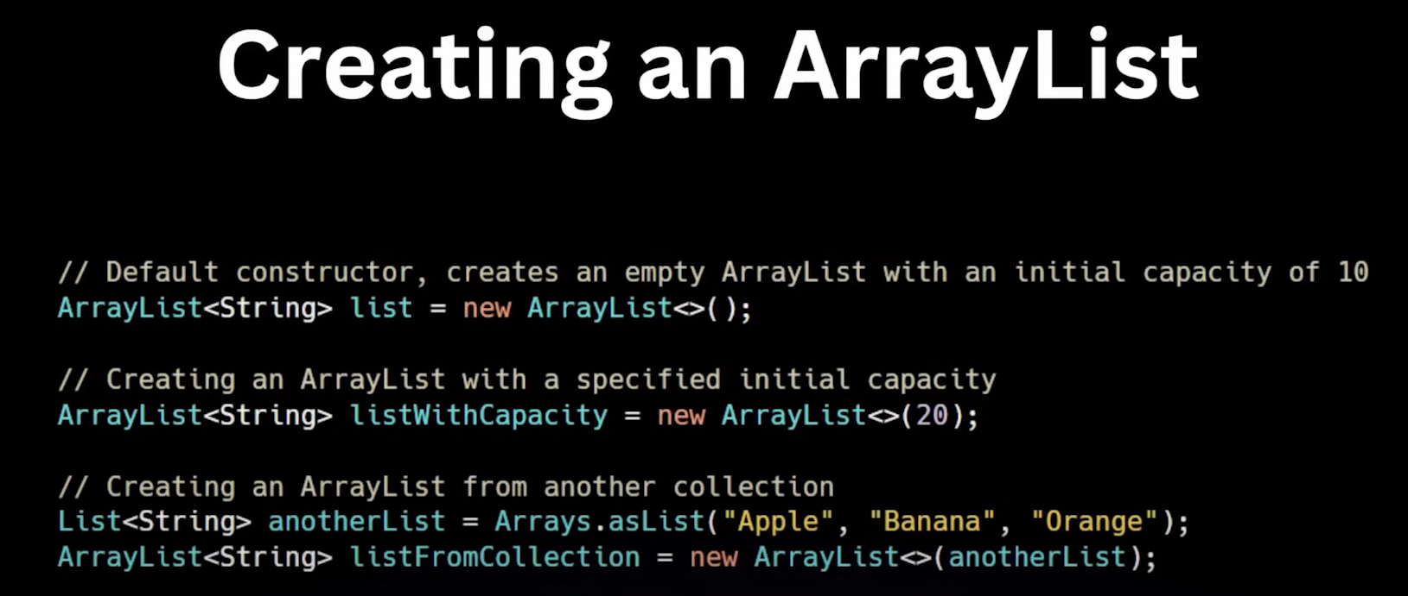

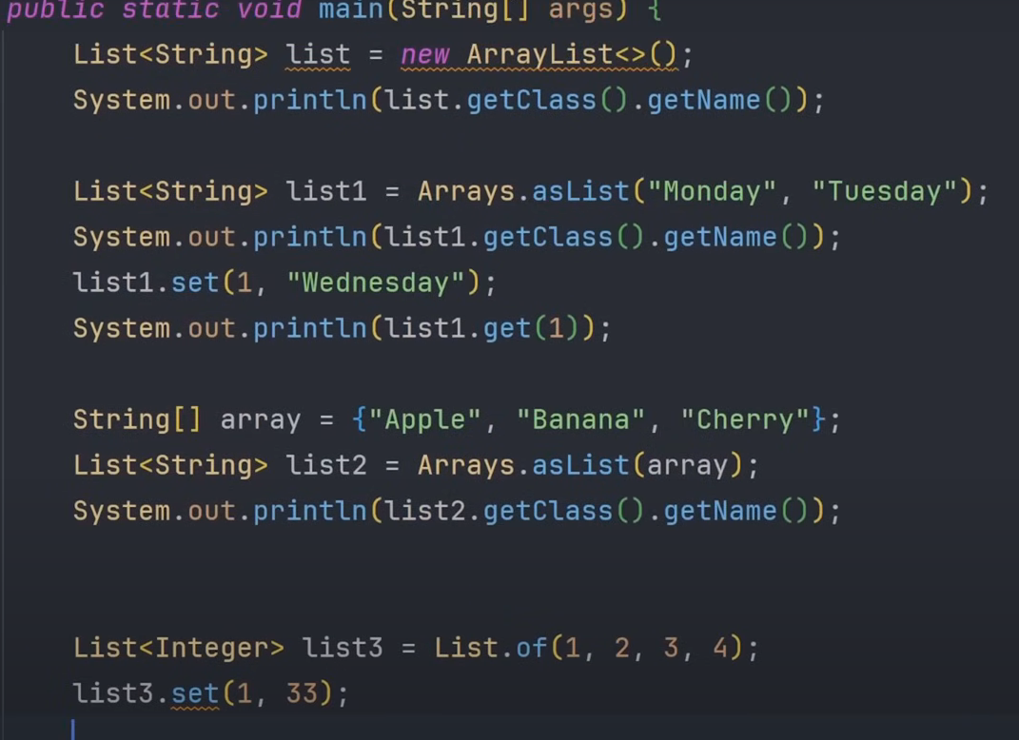

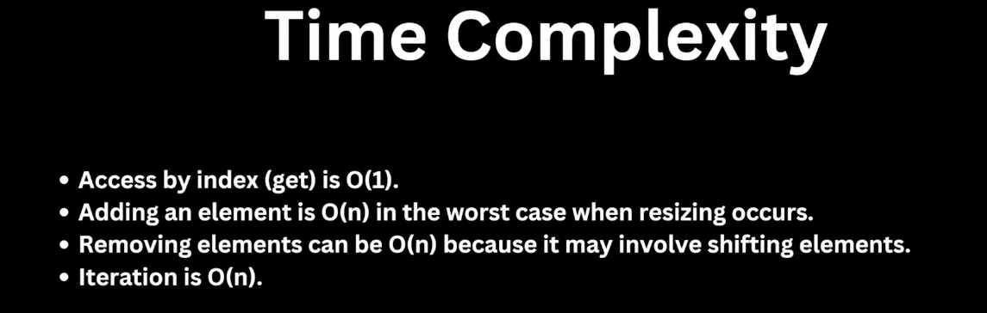

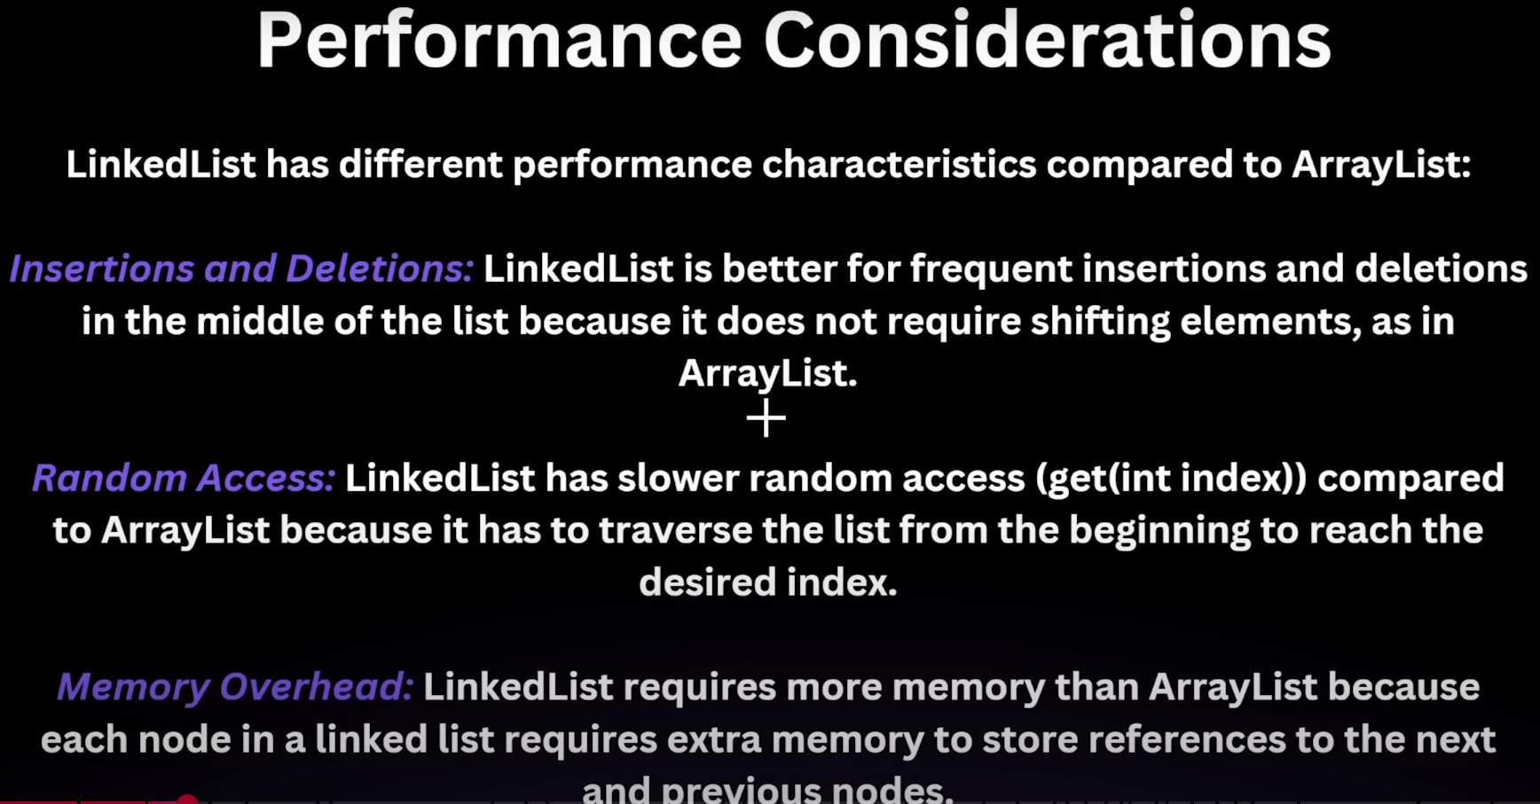

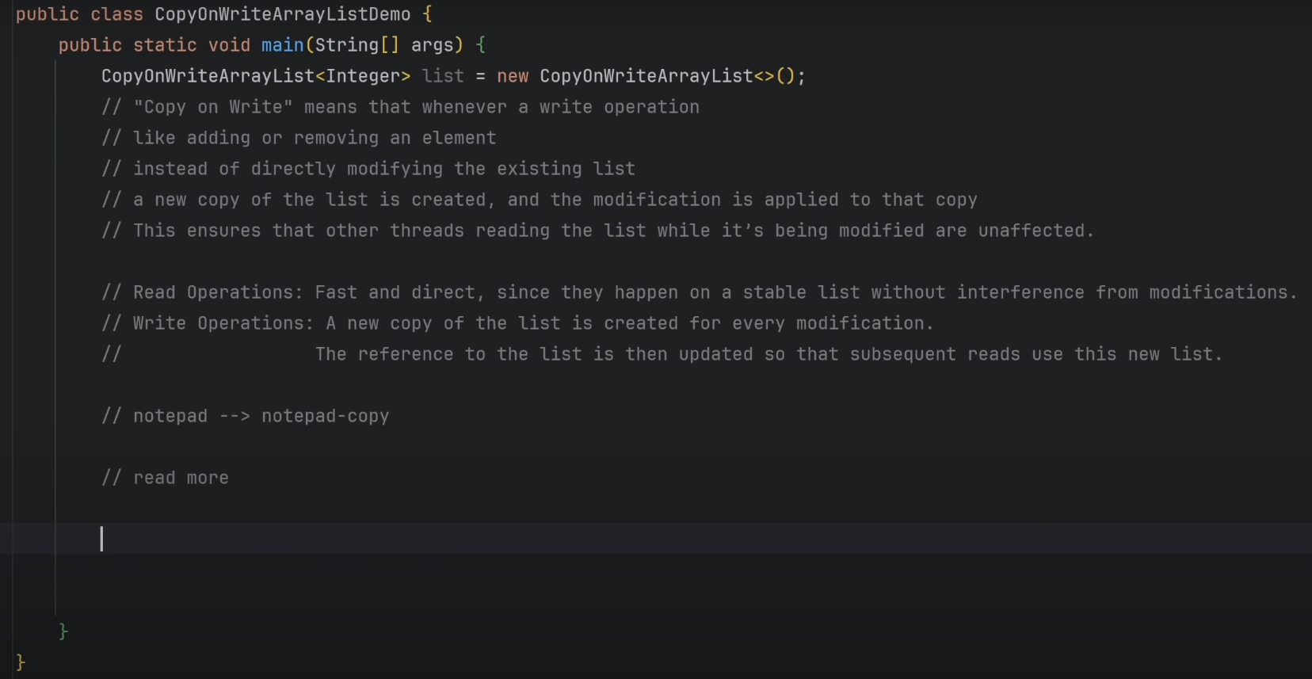

**CopyOnWriteArrayList**

A CopyOnWriteArrayList is a thread-safe variant of the ArrayList in Java's java.util.concurrent package. It was introduced in **JDK 1.5** as part of the Java Concurrency API.

**How it works (in short):**

The core idea of CopyOnWriteArrayList is in its name: **"Copy On Write."**

* **Reads:** When you read from a CopyOnWriteArrayList, threads can access the underlying array directly without any locks. This makes read operations very fast and non-blocking.
* **Writes (Modifications):** When you perform a write operation (like add(), remove(), or set()), instead of modifying the existing array in place, CopyOnWriteArrayList **creates a brand new copy of the entire underlying array.** The modification is then applied to this new copy. Once the modification is complete, the internal reference is updated to point to the new array.

**Why it came (the problem it solves):**

CopyOnWriteArrayList was introduced to address a common concurrency problem with traditional ArrayList (and other unsynchronized collections) when dealing with **frequent read operations and infrequent write operations**.

The problem with ArrayList in a multi-threaded environment is that if one thread is iterating over the list (reading) and another thread modifies it (writing) concurrently, you can get a ConcurrentModificationException. To prevent this with a regular ArrayList, you would typically need to use explicit synchronization (e.g., Collections.synchronizedList or synchronized blocks) around all read and write operations. This can lead to:

* **Performance bottlenecks:** Locking for every read operation, even if the list isn't being modified, can be very inefficient, especially in read-heavy scenarios.
* **Complexity:** Managing locks correctly can be tricky and prone to errors (deadlocks, forgotten locks).

CopyOnWriteArrayList solves this by:

* **Ensuring Thread Safety for Iterations:** Since iterators operate on an immutable snapshot (the old array copy), they are guaranteed not to throw ConcurrentModificationException, even if the list is modified by other threads. The iterator simply sees the state of the list at the time it was created.
* **Optimizing for Reads:** Reads are lock-free and therefore very fast.

**In summary:**

CopyOnWriteArrayList is a specialized thread-safe list ideal for scenarios where **reads vastly outnumber writes**. It achieves thread safety during modifications by creating a new copy of the array, ensuring that ongoing read operations are never interfered with. While efficient for reads, it's generally **not suitable for scenarios with frequent write operations** due to the overhead of copying the entire array with each modification.

